|  |  |
| --- | --- |
| \\VFILERDPI\DPI-Home\OBRIENR2\My Documents\Downloads\PP logo.jpg |  |
| **COUNCIL ASSESSMENT REPORT**  SYDNEY SOUTH PLANNING PANEL | |

|  |  |
| --- | --- |
| PANEL REFERENCE & DA NUMBER | PPSSSH-178 – DA No. 1049/2024 |
| PROPOSAL | Demolition of existing structures and construction of a 4 storey and 5 storey affordable housing residential flat building comprising 42 apartments over basement carparking |
| ADDRESS | Lot 42,43,44,45 DP 35211  171 Weston Street & 2, 4 & 6 Hinemoa Street, Panania |
| APPLICANT | NSW Land and Housing Corporation |
| OWNER | NSW Land and Housing Corporation |
| DA LODGEMENT DATE | 11 October 2024 |
| APPLICATION TYPE | Development Application/CROWN DA |
| REGIONALLY SIGNIFICANT CRITERIA | Section 2.19(1) and Section 4 of Schedule 6 of *State Environmental Planning Policy (Planning Systems) 2021* declares the proposal regionally significant development as:  The Development is carried out by or on behalf of the Crown with an estimated development cost of more than $5 million |
| CIV | $23,420,246 (excluding GST) |
| CLAUSE 4.6 REQUESTS | Wall height variation |
| KEY SEPP/LEP | * State Environmental Planning Policy (Biodiversity and Conservation) 2021 * State Environmental Planning Policy (Housing) 2021 * State Environmental Planning Policy (Sustainable Buildings) 2022 * State Environmental Planning Policy (Planning Systems) 2021 * State Environmental Planning Policy (Resilience and Hazards) 2021 * State Environmental Planning Policy (Transport and Infrastructure) 2021 * Canterbury-Bankstown Local Environmental Plan 2023 |
| TOTAL & UNIQUE SUBMISSIONS KEY ISSUES IN SUBMISSIONS | Four (4) unique submissions |
| DOCUMENTS SUBMITTED FOR CONSIDERATION | * Architectural Plans * Landscape Plan * Stormwater Drainage Plan * Traffic Report * Traffic Impact Assessment * Clause 4.6 Variation Request * Statement Of Environmental Effects * Survey Plan * Cost Estimate Report * Water Management Plan * Rail Impact Assessment Report * Flood Risk Management Report * Rail Monitoring Plan * Fire Engineering Letter * BASIX Certificate * BCA Report * Geotechnical Report * Acoustic Report * Access Report * Arboricultural Impact Assessment * Aboriginal Heritage Information Management Systems (AHIMS) search * Design Verification Statement * Design Review Report * Design Advice Letter |
| SPECIAL INFRASTRUCTURE CONTRIBUTIONS (S7.24) | N/A |
| RECOMMENDATION | Approval |
| DRAFT CONDITIONS TO APPLICANT | YES |
| SCHEDULED MEETING DATE | 14 April 2025 |
| PLAN VERSION | 2 February 2025  Project Reference: PANANIA – LAHC 2021/505  Project No. 21042  Issue B  Version Description: ‘DA Mods’ |
| PREPARED BY | George Telo |
| DATE OF REPORT | 7 April 2025 |

# EXECUTIVE SUMMARY

Development Application DA-1049/2024 is referred to the Sydney South Planning Panel (‘the Panel’) for determination. The proposed development is ‘regionally significant development’, pursuant to Clause 2.19(1) of Chapter 2 and Clause 4 of Schedule 6 of State Environmental Planning Policy (Planning Systems) 2021, as the development is proposed by the Crown and has an estimated development cost of more than $5 million

The development application seeks consent for the demolition of existing structures and construction of a 4-storey and 5-storey affordable housing residential flat building comprising 42 apartments over basement carparking.

The subject development site comprises four allotments legally described as Lots 42, 43, 44 and 45 DP 35211 and individually known as 171 Weston Street and 2,4,6 Hinemoa Street, Panania. The development site forms a largely rectangular shaped allotment with a slight concave along the southern boundary, comprising a total site area of 2,264.75m2, with a frontage length of approximately 46.7m to Weston Street, a secondary frontage length of approximately 53.2m to Hinemoa Street, a rear southern boundary length of approximately 45.2.m, and a west side boundary length of 47.7m.

The development site is situated on the corner of Weston Street and Hinemoa Street, located on the southern side of Weston Street and the western side of Hinemoa Street. Opposite the site, on the northern side of Weston Street, is a railway corridor.

The development site currently contains a single storey dwelling house on each of the respective lots and contains 18 trees across the lots, and 4 street trees situated on the adjacent road reserve. The topography of the land slopes towards Weston Street with a cross fall of approximately 3.1m running from the south-eastern corner of the site (RL21.99) towards the north-western corner of the site (RL18.88). The properties identified as Lot 43,44 & 45 are burdened by an easement to drain water approximately 1.8 metres wide which runs for the full width of the lots, perpendicular to the northern boundary; registered under Dealings No. G126381 & No. G591748 on DP35211.

The subject site is located in an established low density residential area which has recently been rezoned from R2 Low Density Residential to R4 High Density Residential and is subsequently projected to undergo a significant transition. The site is located approximately 300m to the east of Panania Train station.

DA-1049/2024 has been assessed against the principal planning controls relevant to the proposal, which include the following:

* State Environmental Planning Policy (Biodiversity and Conservation) 2021;
* State Environmental Planning Policy (Sustainable Buildings) 2022;
* State Environmental Planning Policy (Housing) 2021
* State Environmental Planning Policy (Planning Systems) 2021;
* State Environmental Planning Policy (Resilience and Hazards) 2021;
* State Environmental Planning Policy (Transport and Infrastructure) 2021;
* Canterbury-Bankstown Local Environmental Plan 2023;
* Canterbury-Bankstown Development Control Plan 2023

The proposal is inconsistent with various provisions of the planning controls including:

* Failure to comply with the height of building development standard under the Canterbury-Bankstown Local Environmental Plan 2023 and State Environmental Planning Policy (Housing) 2021.
* The provisions of the Apartment Design Guide (ADG) including the location of the substation within the front setback (Part 3C); setbacks to the side boundaries relating to the western setback and balconies on levels 2 and 3 (Part 3F) and the minimum area of one of the ground floor terraces (Part 4E-1).

The application relies on a Clause 4.6 variation for the breach to the height of building development standard under the Housing SEPP.

The proposal necessitated the requirement for referral to agencies for concurrence pursuant to State Environmental Planning Policy (Transport and Infrastructure) 2021 (‘Transport and Infrastructure SEPP’). Referral to Transport for NSW (Sydney Trains) and Ausgrid were made and no objections were raised by either agency.

The application was placed on public exhibition for twenty-one (21) days from 30 October 2024 to 20 November 2024, with four (4) submissions being received. These submissions raised issues relating to building height, streetscape and site context, views, street parking and overshadowing impacts. These issues are considered further in this report.

A briefing was held with the Panel on 3 December 2024 where key issues were discussed, including the exceedance of the development standard of building height requiring a Clause 4.6 statement, as well as ADG non-compliances including balcony separation, and communal open space. The location of the substation was also raised as a concern.

Amended plans were submitted seeking to resolve the key issues as noted in the preliminary briefing, which are summarised below:

* Due to site constraints, the relocation of services as suggested is not achievable. However, the landscape plan has been revised to provide more screening and vegetation to soften the impact of the substation. The application was reviewed by Ausgrid, who had no objection to the development.
* Balconies that were affected by the visual privacy separation of buildings objective have incorporated privacy screening to mitigate any overlooking concerns.
* The communal open space areas located at the rear of the development have been redesigned to achieve the minimum area requirements.

Following consideration of the matters for consideration under Section 4.15(1) of the *Environmental Planning & Assessment Act, 1979* (‘the EP&A Act’), which included an assessment against the provisions contained within the relevant State and local environmental planning policies, the proposal is worthy of support. The development is not considered to result in any unacceptable adverse environmental impacts and is not contrary to the public interest. It has been demonstrated that the development is suitable for the site and its surrounds, and through its innovative design would maintain and protect the amenity of the adjoining properties.

In accordance with the procedure set out in section 4.33(1)(b) of the EP&A Act, Homes NSW, acting on behalf of the Crown, have reviewed Council’s conditions of consent and have provided their approval. A copy of the approval is contained at **Attachment B** of this report.

Following a detailed assessment of the proposal, pursuant to Section 4.16(1)(a) of the *EP&A Act*, DA-1049/2024 is recommended for approval subject to the reasons contained at **Attachment A** of this report.

# THE SITE AND LOCALITY

* 1. **The Site**

The subject development site comprises four allotments legally described as Lots 42, 43, 44 and 45 DP 35211 and individually known as 171 Weston Street and 2,4,6 Hinemoa Street, Panania. The development site forms a largely rectangular shaped allotment with a slight concave along the southern boundary, comprising a total site area of 2,264.75m2, with a frontage length of approximately 46.7m to Weston Street, a secondary frontage length of approximately 53.2m to Hinemoa Street, a rear southern boundary length of approximately 45.2.m, and a west side boundary length of 47.7m.

The development site is situated on the corner of Weston Street and Hinemoa Street, located on the southern side of Weston Street and the western side of Hinemoa Street. Opposite the site, on the northern side of Weston Street, is a railway corridor.

The development site currently contains a single storey dwelling house on each of the respective lots and contains 18 trees across the lots, and 4 street trees situated on the adjacent road reserve. The topography of the land slopes towards Weston Street with a cross fall of approximately 3.1m running from the south-eastern corner of the site (RL21.99) towards the north-western corner of the site (RL18.88). The properties identified as Lot 43,44 & 45 are burdened by an easement to drain water approximately 1.8 metres wide which runs for the full width of the lots, perpendicular to the northern boundary; registered under Dealings No. G126381 & No. G591748 on DP35211.

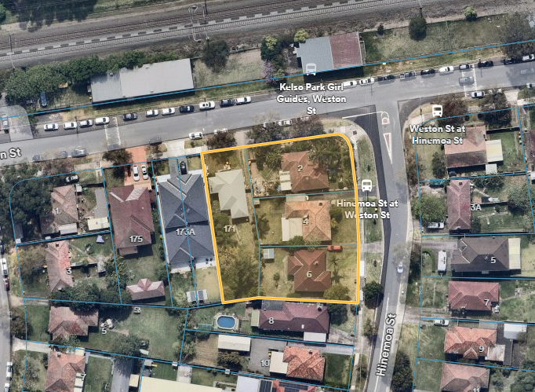

Figure 1 Aerial view of 171 Weston Street &, 2,4,6 Hinemoa Street, Panania; sites outlined in yellow. Source: NearMap (2024)

* 1. **The Locality**

The subject site is located in an established low density residential area which has recently been rezoned from R2 Low Density Residential to R4 High Density Residential and is subsequently projected to undergo a significant transition. The site is located approximately 300m to the east of Panania Train station.

Residential development in the surrounding area predominantly consists of 1 and 2 storey detached dwelling houses and dual occupancies, with some infill multi dwelling housing and seniors housing developments. A 2-storey dual occupancy development is located on the adjoining property to the west of the subject site at 173 Weston St (**Figure 2**). A single storey detached dwelling house of brick and tile construction is located to the south of the development site at 8 Hinemoa Street (**Figure 3)**.

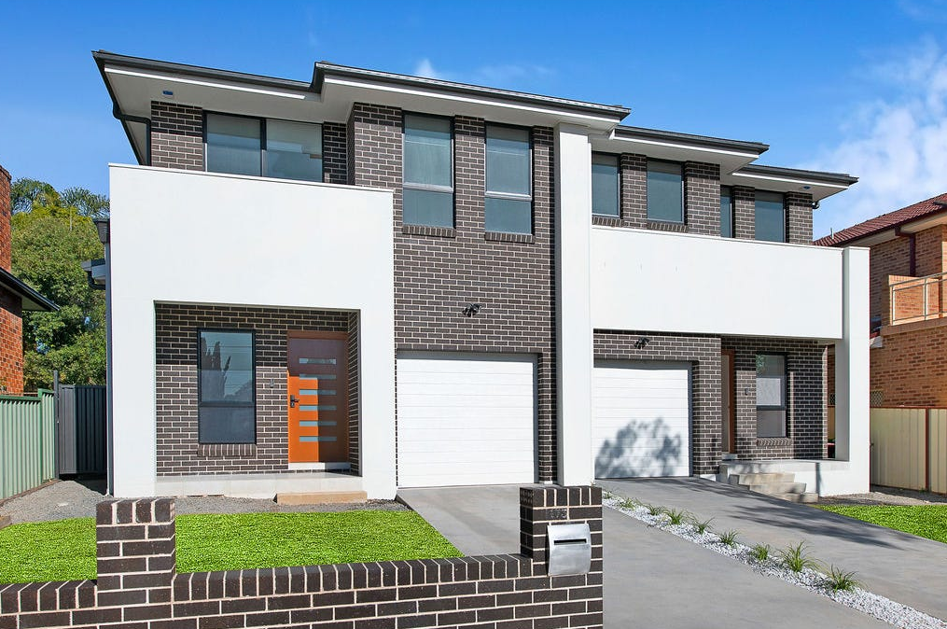

Figure 2 173 Weston Street, Panania. Source: Realestate.com.au (2024)

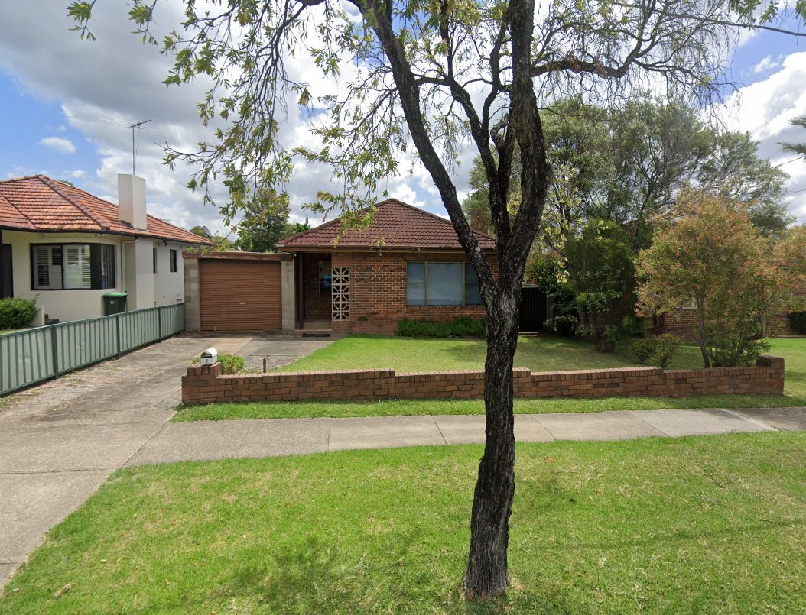

Figure 3 - 8 Hinemoa Street, Panania. Source: Google Maps (2024)

The surrounding locality comprises a mix of residential, commercial, recreational, and educational uses. The Panania Town Centre and Panania Train Station are located approximately 300m to the west of the subject site. The Panania local centre includes local shops, post office, supermarket, medical and community facilities, library, restaurants, and public hotel. Additional shops and restaurants are located along Tower Street, approximately 200m to the south of the site. The land on the eastern side of Hinemoa Street, directly opposite to the subject site, is zoned R3 Medium Density Residential.

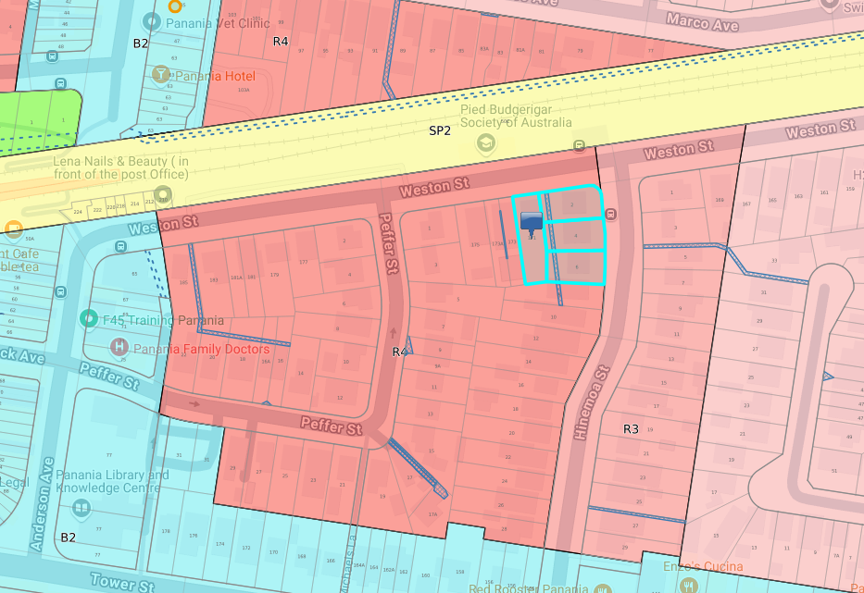

The site is situated directly across two bus stops located along Hinemoa Street, and on the northern side of Weston Street, opposite the site.

* Hinemoa St at Weston St (Stop ID: 221329) – in front of the site between 2-4 Hinemoa St, and
* Kelso Park Girl Guides, Weston St (Stop ID: 221355) – opposite the site, approx. 20m to the north.

# THE PROPOSAL AND BACKGROUND

* 1. **The Proposal**

In accordance with Section 4 under Schedule 6 of SEPP (Planning Systems) 2021, development carried out by or on behalf of the Crown that has an estimated development cost of more than $5 million is considered ‘regionally significant development’.

The proposal seeks consent for the construction of a 4-storey and 5-storey residential flat building comprising 42 affordable housing units, basement parking for 19 vehicles, associated site and civil works, landscaping and fencing, in addition to lot consolidation, pursuant to the affordable housing provisions of the Housing SEPP. This application is for community infrastructure (affordable housing) and has a Capital Investment Value greater than $5 million, and therefore is subject to determination by the Sydney South Planning Panel.

Specifically, the proposal involves:

* Consolidation of the four lots into one allotment;
* Relocation of existing drainage easement;
* Removal of 13 trees within the site, including 1 street tree;
* Construction of a 5-storey residential flat building at the front of the site (Block B) containing 26 units;
* Construction of a 4-storey residential flat building at the rear of the site (Block A) containing 16 units;
* Basement car parking to accommodate 19 vehicles, including 5 accessible spaces, 6 bicycle parking spaces / racks, storage cages, hydrant pump room, meter panels, switchboard room, hot water plant, and cold water plant;
* Construction of a new driveway for vehicular access to the site from Hinemoa Street;
* Private open space areas for each dwelling in the form of courtyards or balconies which are directly accessible off living areas;
* Pedestrian access points connected to a newly constructed footpath along Weston Street and Hinemoa Street;
* Bin room integrated into the 5-storey residential flat building with direct pedestrian access to Weston Street and sized to accommodate waste bins;
* Basement stormwater pump out system with a 20,500 litre capacity storage tank;
* Onsite stormwater detention in an underground tank with a capacity of 28.31m3 (28,310 litres);
* Associated landscape and civil works;
* Extensive landscaping scheme, including the provision of trees and a variety of shrub and groundcover plantings and landscaping structures across the site.

The key development data is provided in **Table 1**.

**Table 1: Key Development Data**

|  |  |
| --- | --- |
| **Control** | **Proposal** |
| Site area | 2,264.75m2 |
| GFA | 3,283.2m2 |
| FSR (residential) | 1.45:1 |
| Clause 4.6 Requests | Building Height  Clause 18(2) of Part 2 Division 1 of the Housing SEPP |
| No. of apartments | 42 (22 x 1 bedroom units &, 20 x 2 bedroom units) |
| Max Height | 17.44m |
| Landscaped area | Deep Soil Area at rear of development – 381m2  Landscaped area - 816m2 |
| Car Parking spaces | 19 parking spaces contained within basement level, including 5 accessible |
| Setbacks | 6m setback to Hinemoa Street  3.6m to Weston Street  4.9m to western boundary |
| Cross ventilation | 61.9% (26/42) |
| Solar access | 78.6% (33/42) |
| Communal Open Space | 566m2 |

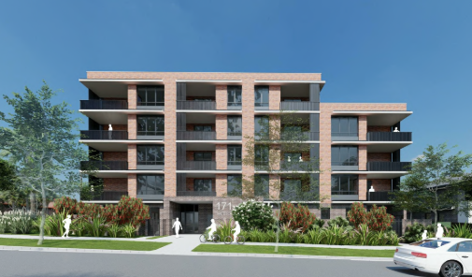

Figure 4: 3D render of Architectural Plans - Northern facade facing Weston Street. Source: Morson Group, 30.08.2024

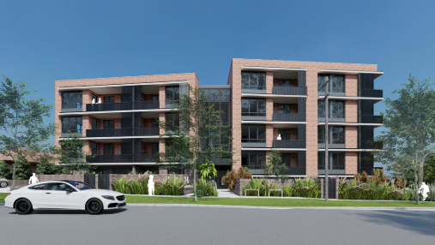

Figure 5: 3D render of Architectural Plans - Eastern facade facing Hinemoa Street. Source: Morson Group, 30.08.2024

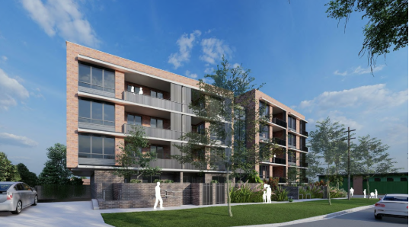

Figure 6: 3D render of Architectural Plans – South-Eastern facade facing Hinemoa Street. Source: Morson Group, 30.08.2024

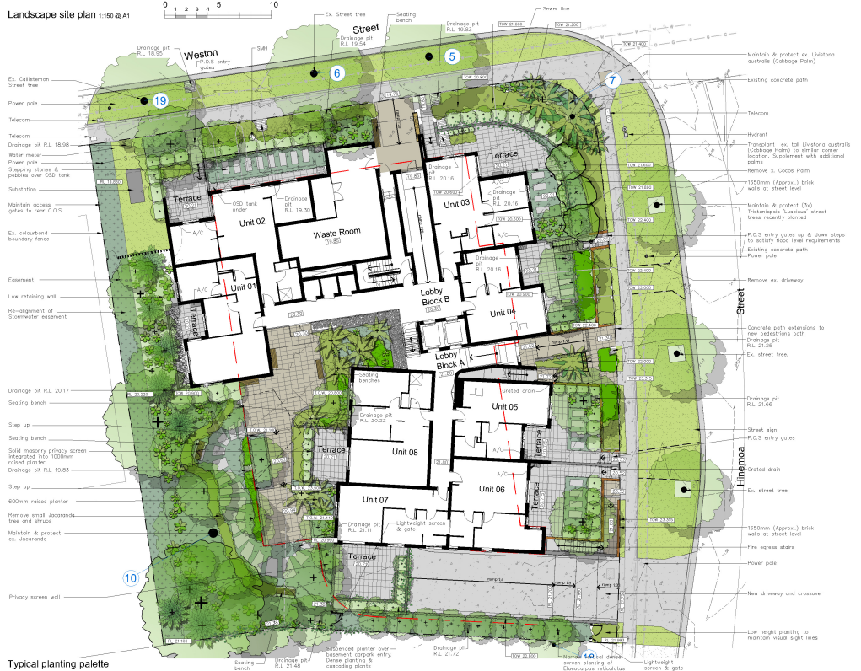

Figure 7: Concept Landscape Plan. Source: Paul Scrivener Landscape, 2.9.24

* 1. **Background**

Pre-DA Advice

Council was provided the opportunity to review the development proposal prior to the subject DA being submitted. Written advice was provided to the applicant on 13 May 2024 in response to a proposed building form (which is similar to that which is submitted under the subject application, i.e. 4 storey and 5 storey residential flat building). It was advised as part of the Pre-DA that any DA submission would need to be supported by further detail regarding landscaping and solar access and a detailed ADG assessment would be undertaken.

Design Review Panel

To ensure the proposed design of the development meets the requirements of Section 6.15 *Design Excellence* of the CBLEP, the development proposal was presented to the Design Review Panel on 11 July 2024. The Panel reviewed the design concept and as a result provided advice and recommendations for the applicant to consider in the final design. In summary, the advice for further improvement provided by the Panel included matters relating to bulk and massing, privacy and access to private open spaces, and improved access to natural light within apartments.

The Panel confirmed that once the recommendations as specified in the Design Advice Letter of 11 July 2024 are implemented, the application will not require any further review by the DRP. In this regard, Council’s Urban Design officers requested the applicant submit a Design Review Report (DRR) as part of the submission of a Development Application. The Design Review Report should summarise the design development process undertaken in response to the recommendations outlined in the Design Advice Letter to streamline the assessment process.

The development application was lodged on 11 October 2024. A chronology of the development application since lodgement is outlined in **Table 2**.

**Table 2: Chronology of the DA**

|  |  |
| --- | --- |
| **Date** | **Event** |
| 11 October 2024 | DA officially lodged with Council |
| 30 October 2024 | Exhibition of the application from 30 October 2024 until 20 November 2024 |
| 11 November 2024 | DA referred to external agencies |
| 11 November 2024 | Panel Site Inspection |
| 3 December 2024 | Panel preliminary briefing |
| 5 December 2024 | Response letter received from Sydney Water with conditions |
| 12 December 2024 | Request for Information from Council to applicant |
| 18 December 2024 | Response letter received from Sydney Trains with conditions |
| 30 January 2025 | Response letter received from Ausgrid with conditions |
| 25 February 2025 | Clause 4.6 variation request lodged, seeking variation to the Height of Building Standard, dated 1 February 2025 accepted by Council under Cl 38(1) of the *Environmental Planning and Assessment Regulation 2021* (‘2021 EP&A Regulation’) on 25 February 2025. |
| 25 February 2025 | Amended plans lodged showing changes to landscaping and privacy screening for balconies, dated 24 February 2025 accepted by Council under Cl 38(1) of the *Environmental Planning and Assessment Regulation 2021* (‘2021 EP&A Regulation’) on 25 February 2025. |
| 13 March 2025 | Amended Traffic & Parking Impact Assessment lodged, dated 28 February 2025 accepted by Council under Cl 38(1) of the *Environmental Planning and Assessment Regulation 2021* (‘2021 EP&A Regulation’) on 13 March 2025. |
| 13 March 2025 | Amended landscape plans lodged dated 26 February 2025 accepted by Council under Cl 38(1) of the *Environmental Planning and Assessment Regulation 2021* (‘2021 EP&A Regulation’) on 13 March 2025. |

* 1. **Site History**

There are no previous DA approvals for the subject sites. Historic aerial imagery indicates that the development site has a history of being used for low density residential dwellings.

# STATUTORY CONSIDERATIONS

When determining a development application, the consent authority must take into consideration the matters outlined in Section 4.15(1) of the *Environmental Planning and Assessment Act 1979* (‘EP&A Act’). These matters as are of relevance to the development application include the following:

1. *the provisions of any environmental planning instrument, proposed instrument, development control plan, planning agreement and the regulations*

*(i)  any environmental planning instrument, and*

*(ii)  any proposed instrument that is or has been the subject of public consultation under this Act and that has been notified to the consent authority (unless the Planning Secretary has notified the consent authority that the making of the proposed instrument has been deferred indefinitely or has not been approved), and*

*(iii)  any development control plan, and*

*(iiia)  any planning agreement that has been entered into under section 7.4, or any draft planning agreement that a developer has offered to enter into under section 7.4, and*

*(iv)  the regulations (to the extent that they prescribe matters for the purposes of this paragraph),*

*that apply to the land to which the development application relates,*

1. *the likely impacts of that development, including environmental impacts on both the natural and built environments, and social and economic impacts in the locality,*
2. *the suitability of the site for the development,*
3. *any submissions made in accordance with this Act or the regulations,*
4. *the public interest.*

These matters are further considered below.

It is noted that the proposal:

* Requires concurrence/referral (s4.13)
* Is a Crown DA (s4.33) - written agreement from the Crown to the proposed conditions of consent must be provided
  1. **Environmental Planning Instruments, proposed instrument, development control plan, planning agreement and the regulations**

The relevant environmental planning instruments, proposed instruments, development control plans, planning agreements and the matters for consideration under the Regulation are considered below.

1. **Section 4.15(1)(a)(i) - Provisions of Environmental Planning Instruments**

The following Environmental Planning Instruments are relevant to this application:

* [*State Environmental Planning Policy (Biodiversity and Conservation) 2021*](https://legislation.nsw.gov.au/view/html/inforce/current/epi-2021-0722)
* [*State Environmental Planning Policy (Sustainable Buildings) 2022*](https://legislation.nsw.gov.au/view/html/inforce/current/epi-2004-0396)
* [*State Environmental Planning Policy (Housing) 2021*](https://legislation.nsw.gov.au/view/html/inforce/current/epi-2021-0714)
* [*State Environmental Planning Policy (Resilience and Hazards) 2021*](https://legislation.nsw.gov.au/view/html/inforce/current/epi-2021-0730)
* [*State Environmental Planning Policy (Planning Systems) 2021*](https://legislation.nsw.gov.au/view/html/inforce/current/epi-2021-0731)
* [*State Environmental Planning Policy (Transport and Infrastructure) 2021*](https://legislation.nsw.gov.au/view/html/inforce/current/epi-2021-0732)
* *Canterbury Bankstown Local Environmental Plan 2023*

A summary of the key matters for consideration arising from these State Environmental Planning Policies and Local Environmental Plan are outlined in **Table 3** and considered in more detail below.

**Table 3: Summary of Applicable Environmental Planning Instruments**

|  |  |  |
| --- | --- | --- |
| **EPI** | **Matters for Consideration** | **Comply (Y/N)** |
| State Environmental Planning Policy (Biodiversity & Conservation) 2021 | Chapter 2: Vegetation in non-rural areas  This chapter applies to the removal of vegetation in non-rural areas of Canterbury Bankstown Council and aims to protect the biodiversity values of trees and other vegetation and to preserve the amenity of these areas through the preservation of trees and other vegetation. The DA seeks the removal of 13 trees on the site and 1 street tree and is supported by an Arboricultural Impact Assessment report. Council’s Tree Management team concur with the recommendations provided in the report.  Chapter 6: Water Catchments  This chapter applies to developments on land that is located within the Georges River Catchment. The requirements under this section of the SEPP have been considered as part of the assessment of the application. The development is consistent with the relevant provisions of Chapter 6 of the SEPP. | Y |
| State Environmental Planning Policy (Sustainable Buildings) 2022 | No issues identified, subject to imposition of conditions on any consent granted. | Y |
| State Environmental Planning Policy (Housing) 2021 | Chapter 2: Affordable Housing  Division 1: In-fill affordable housing. This division applies to development that includes residential development if the development is permitted under an environmental planning instrument, and the affordable housing component is at least 10% and the development is carried out on land which is within 800m walking distance of land in a relevant zone.    Part 2, Division 1, Clause 18(2) development standard of the Housing SEPP permits an additional 30% height bonus on top of cl4.3 of the CBLEP 2023 (based on 100% affordable housing provision), resulting in a maximum height of building of 16.9m.  Chapter 4: Design of residential apartment development  This chapter seeks to improve the design of residential flat buildings by providing standards that residential flat buildings should meet. | N |
| ADG  Chapter 4: Section 149 – Design of residential apartment development  The proposal is required to be consistent with the ADG requirements. This section also requires residential apartment developments to be referred to a design review panel, includes non-discretionary standards, and requires compliance with the standards and controls of the ADG. The development was presented to Council’s design review panel prior to the lodgement of the subject DA. Council’s Urban Design team have confirmed that further referral to the Design Review Panel is not required and the issues previously raised by the Panel can be reviewed by the Urban Design team.  Schedule 9 Design Quality Principles  The proposal is required to meet the design quality principles.  The proposal is considered to adequately meet the design quality principles under this Schedule. | N |
| State Environmental Planning Policy (Planning Systems) 2021 | Chapter 2: State and Regional Development   * Section 2.19(1) declares the proposal regionally significant development pursuant to Clause 4 of Schedule 6 as it comprises a Crown development with a CIV of at least $5 million. | Y |
| State Environmental Planning Policy (Resilience & Hazards) 2021 | Chapter 4: Remediation of Land   * Section 4.6 - Contamination and remediation has been considered in the Contamination Report and the proposal is satisfactory subject to conditions. | Y |
| State Environmental Planning Policy (Transport and Infrastructure) 2021 | Chapter 2: Infrastructure  This chapter applies to infrastructure and aims to facilitate the effective delivery of infrastructure across the State.   * Division 5 Electricity transmission or distribution – Subdivision 2 Development likely to affect an electricity transmission or distribution network. * Section 2.48(2) (Determination of development applications—other development) – a referral to the electricity supply authority is required under this Section of the SEPP for the provision of a substation for the development. The application was referred to Ausgrid. A response from Ausgrid has been provided on 30.01.2025 granting concurrence to the development, subject to conditions. * Division 15 Railways – Subdivision 2 Development in or adjacent to rail corridors and interim rail corridors – notification and other requirements. * Section 2.98 (Development adjacent to rail corridors) – a referral to the rail authority is required under this Section of the SEPP for consideration of the likely impacts on the rail corridor as a result from the development. The application was referred to TfNSW. A response from TfNSW has been provided on 18.12.2024 granting concurrence to the development, subject to operational conditions being imposed on the consent. * Section 2.99 (Excavation in, above, below or adjacent to rail corridors) – a referral to the rail authority is required under this Section of the SEPP for consideration of the likely impacts on the rail corridor as a result from the development. The application was referred to TfNSW. A response from TfNSW has been provided on 18.12.2024 granting concurrence to the development, subject to operational conditions being imposed on the consent. | Y |
| Canterbury Bankstown Local Environmental Plan 2023 | * Clause 2.3 – Zone objectives and Land Use Table.   + The proposed development is permissible with consent in the R4 High Density Residential Zone. * Section 4.3 – Height of buildings   + The maximum permissible building height for this site is 13m.   + The development benefits from a 30% height allowance under Division 1 Chapter 2 of the Housing SEPP, meaning the maximum height increases to 16.9m.   + The application seeks a variation, proposing a building height of 17.44m, which fails the standard. A clause 4.6 variation is submitted in support of this, which is supported by Council. * Section 4.4 – Floor Space Ratio   + The maximum permissible FSR for this site is 1:1.   + The development benefits from a 0.5:1 additional FSR allowance under Division 1 Chapter 2 of the Housing SEPP.   + The application proposes an FSR or 1.45:1 which is compliant. * Section 4.6 – Exception to development standards   + A clause 4.6 variation report has been submitted with the application for the breach to the height control, which has been considered by Council. * Section 6.2 – Earthworks   + The application seeks consent involving excavation works to accommodate a basement car park for the development, with an approximate excavation depth of 3.8m. A Geotechnical Investigation report is submitted in support of the DA. * Section 6.3 – Stormwater management and water sensitive urban design   + Council’s Development Engineer has reviewed the proposed stormwater drainage design for the development and has found it acceptable subject to conditions. * Section 6.8 – Airspace operations   + The site has a OLS limitation of 51m. The building height of the proposed development does not exceed the OLS height and therefore will not require a controlled activity approval within the meaning of the Airports Act 1996. * Section 6.9 – Essential services   + The site is currently used for residential purposes and therefore will have access to essential services. * Section 6.15 – Design excellence   + The aim of this section is to ensure that development exhibits high quality architectural, urban and landscape design. The proposal was presented to Council’s Design Review Panel prior to the lodgement of the subject DA. The Panel was supportive of the proposal, subject to a number of design changes which have been accommodated in the current design scheme. | N |

Consideration of the relevant SEPPs is outlined below:

[***State Environmental Planning Policy (Biodiversity and Conservation) 2021***](https://legislation.nsw.gov.au/view/html/inforce/current/epi-2021-0722)

The proposal has been assessed against the relevant aims and objectives of this Policy which aims to protect the biodiversity values of trees and other vegetation and to preserve the amenity of these areas through the preservation of trees and other vegetation.

Chapter 2: Vegetation in non-rural areas

The DA seeks the removal of 13 trees on the site and 1 street tree, and is supported by an Arboricultural Impact Assessment report. Council’s Tree Management team concur with the recommendations provided in the report.

Chapter 6: Water Catchments

The development is on land that is located within the Georges River Catchment. The requirements under this section of the SEPP have been considered as part of the assessment of the application. The development is consistent with the relevant provisions of Chapter 6 of the SEPP.

[***State Environmental Planning Policy (Sustainable Buildings) 20***](https://legislation.nsw.gov.au/view/html/inforce/current/epi-2004-0396)***22***

State Environmental Planning Policy (Sustainable Buildings) *2022* applies to the proposal. The objectives of this Policy are to ensure that the performance of the development satisfies the requirements to achieve water and thermal comfort standards that will promote a more sustainable development.

The application is accompanied by BASIX Certificate No.1762086M prepared by PEM GROUP CO PTY LTD dated 29 August 2024 committing to environmentally sustainable measures. The Certificate demonstrates the proposed development satisfies the relevant water, thermal and energy commitments as required by the Sustainable Buildings SEPP. The proposal is consistent with the SEPP subject to the recommended conditions of consent.

[***State Environmental Planning Policy (Housing) 2021***](https://legislation.nsw.gov.au/view/html/inforce/current/epi-2021-0714)

State Environmental Planning Policy (Housing) 2021 applies to the proposal. The aim of this Policy is to enable the development of diverse housing types through the promotion of the planning and delivery of housing in locations where it will make good use of existing and planned infrastructure, in order to ensure that new housing developments provide residents with a reasonable level of amenity.

Division 1 of Chapter 2, In-fill affordable housing, applied to this proposal. This division applies to development that includes residential development if the development is permitted under an environmental planning instrument and the affordable housing component is at least 10% and the development is carried out on land which is within 800m walking distance of land in a relevant zone.

Division 1 of Chapter 2 provides building height allowances for developments carried out by or on behalf of the Land and Housing Corporation, in which the affordable housing component of the development makes up more than 10%, and Floor Space Ratio allowances for developments with an affordable housing component of more than 20%. Accordingly, the proposal benefits from a building height allowance of an additional 30% and an FSR allowance of an additional 0.5:1.

Chapter 4: Design of residential apartment development

This chapter seeks to improve the design of residential flat buildings by providing standards that residential flat buildings should meet.

Chapter 4: Section 149 – Design of residential apartment development

The proposal is required to be consistent with the ADG requirements which prevail over development control plans. This section also requires residential apartment developments to be referred to a design review panel, includes non-discretionary standards, and requires compliance with the standards and controls of the ADG. The development was presented to Council’s design review panel prior to the lodgement of the subject DA. Council’s Urban Design team have confirmed that further referral to the Design Review Panel is not required and the issues previously raised by the Panel can be reviewed by the Urban Design team.

Schedule 9 Design Quality Principles

The proposal is required to meet the design quality principles.

* Principle 1 - Context and neighbourhood character

The proposal addresses both frontages’ contexts adequately as the development transitions from the busier character of Weston Street toward the rail corridor, to the more residential and quieter Hinemoa Street.

* Principle 2 - Built form and scale

The proposal responds to streetscape and optimises solar access by locating larger built masses on the northern part of the site as a transition to the residential buildings on the south and east of the site. Steps have been taken to ensure that building mass is setback adequately from the surrounding developments to mitigate any overshadowing and maintain solar access.

The proposal is under the maximum floor space ratio limit, however, does exceed the maximum wall height for a portion of the parapet. A clause 4.6 has been submitted to council for consideration regarding this contravention.

* Principle 3 – Density

The proposed built form of the development has been envisioned in the recently adopted Canterbury-Bankstown LEP and DCP, as the area transitions to greater density in line with the strategic vision of the applicable planning documents.

* Principle 4 – Sustainability

Steps have been taken to reduce impacts of overshadowing, wind and reflectivity, as well as the integration of native species into the landscape. As recommended by the Design Review Panel, PV panels have been provided and are shown on the roof plan. A 42KW system is shown on the plans and committed to in the Basix Report. Furthermore, provision for EV charges will be allowed for in the basement carpark. The landscape design provides for a mixture of native and exotic planting species which support and contribute to the Cumberland Plain ecological context.

* Principle 5 – Landscape

The proposal maintains where possible a continuous strip of planting along the street frontages between the property boundary and the ground level courtyards. The landscape plan shows extensive planting and substantial trees to the southwest corner as recommended. The side and rear setbacks have been designed with landscape zones suitable in width and soil depths to permit screen planting between the proposal and the neighbouring properties. The landscape plans show the cabbage palm retained in place without any relocation. The cabbage palm is a native species and is a valuable contribution to the landscape design and streetscape.

* Principle 6 – Amenity

The proposal demonstrates good design which positively influences the internal and external amenity for residents and neighbours. The proposed layout allows for sufficient communal open space, as well as appropriate room sizes and access to sunlight and ventilation. The apartments have been positioned in a way to ensure that visual privacy is upheld for both the residents and neighbours.

* Principle 7 – Safety

The proposal prioritises safety through thoughtful design choices. Communal open spaces have been carefully planned to maximise passive surveillance within the public domain. Building entries are clearly visible and strategically located to eliminate any hidden blind spots that could obstruct sightlines. Additionally, the balconies have been designed with safety in mind, incorporating features that prevent climbing, thereby ensuring the safety and well-being of residents.

* Principle 8 - Housing diversity and social interaction

The local area is undergoing transition from low-density to a high-density residential environment, which is congruent with the current zoning that applies to the site. The proposed level of development is envisioned for this part of Panania by the CBLEP 2023, which is in a highly accessible precinct serviced by rail and bus public transport services and is near the services and facilities of the Panania Town Centre. The development proposes a mix of 1-bedroom and 2-bedroom dwellings to provide a mix of apartment sizes for different demographics, living needs and budgets.

* Principle 9 – Aesthetics

The aim of this Principle is to ensure that development exhibits high quality architectural, urban and landscape design. The proposal was presented to Council’s Design Review Panel prior to the lodgement of the subject DA. The Panel was supportive of the proposal, subject to a number of design changes which have been accommodated in the current design scheme.

The proposal is considered to adequately meet the design quality principles under this Schedule.

**Apartment Design Guide**

The following table provides an assessment of the development against the design criteria in the ADG. A full assessment against the provisions contained in the ADG is provided at Appendix C.

| **STATE ENVIRONMENTAL PLANNING POLICY (HOUSING) 2021**  **CHAPTER 4 DESIGN OF RESIDENTIAL APARTMENT DEVELOPMENT**  **NSW APARTMENT DESIGN GUIDE PART 3** | | | | | |
| --- | --- | --- | --- | --- | --- |
|  | | | Compliance | | |
| Y | N | N/A |
| **Design Criteria**  **3D-1** | An adequate area of communal open space is provided to enhance residential amenity and to provide opportunities for landscaping.   1. Communal open space has a minimum area equal to 25% of the site area. 2. Developments achieve a minimum of 50% direct sunlight to the principal usable part of the communal open space for a minimum of 2 hours between 9am and 3pm on 21 June (mid winter). | Complies Approximately 566sqm provided.  The proposed communal open space receives the minimum required solar access from 1pm  to 3pm on the winter solstice. | x |  |  |
| **Design Criteria**  **3E-1** | 1. Deep soil zones are to meet the following minimum requirements: | 158.55sqm required 431sqm provided | x |  |  |
| |  |  |  | | --- | --- | --- | | **Site Area** | **Min. Dimension** | **DSZ (% of site)** | | **Less than 650m2** | - | 7% | | **650 m2- 1,500 m2** | 3m | 7% | | **Greater than 1,500 m2** | 6m | 7% | | **Greater than 1,500 m2 with existing tree cover** | 6m | 7% | | **Note: 10% deep soil for sites 650-1,500m2 and 15% deep soil for sites greater than 1,500m2.** | | | | |
| **Design Criteria**  **3F-1** | 1. Separation between windows and balconies is provided to ensure visual privacy is achieved. Minimum required separation distances from buildings to the side and rear boundaries are as follows: | Not all balconies are separated 6m – however sufficient screening has been provided to mitigate any opportunities for overlooking  Side setback from the balconies of units 9,10,19,20,29,30 to the side (western) boundary is 5.7m, a shortfall of 0.3m |  | x |  |
| |  |  |  | | --- | --- | --- | | **Building Height** | **Habitable Rooms / Balconies** | **Non-Habitable Rooms** | | **12m (4 storeys)** | 6m | 3m | | **25m (5-8 storeys)** | 9m | 4.5m | | **25m+ (9+ storeys)** | 12m | 6m | | **Note: Separation distances between buildings on the same site should combine required building separations depending on the type of room.** | | | | **Gallery access circulation should be treated as habitable space when measuring privacy separation distances between neighbouring properties.** | | | | |
| **Design Criteria**  **3J-1** | 1. For development in the following locations:    * on sites that are within 800 metres of a railway station or light rail stop in the Sydney Metropolitan Area; or    * on land zoned, and sites within 400 metres of land zoned, B3 Commercial Core, B4 Mixed Use or    * equivalent in a nominated regional centre   The minimum car parking requirement for residents and visitors is set out in the Guide to Traffic Generating Developments, or the car parking requirement prescribed by the relevant council, whichever is less  The car parking needs for a development must be provided off street. | The development requires 19 car parking spaces under the provisions of the Housing SEPP.  19 car parking spaces have been proposed.  The following number of parking spaces for dwellings used for affordable housing—  (i)  for each dwelling containing 1 bedroom—at least 0.4 parking spaces,  (ii)  for each dwelling containing 2 bedrooms—at least 0.5 parking spaces,  20 x 1 Bedroom  22 x 2 Bedroom  (20 x 0.4) + (22 x 0.5)  8+11 = 19 | x |  |  |

| **STATE ENVIRONMENTAL PLANNING POLICY (HOUSING) 2021**  **CHAPTER 4 DESIGN OF RESIDENTIAL APARTMENT DEVELOPMENT**  **NSW APARTMENT DESIGN GUIDE PART 4** | | | | | | | |
| --- | --- | --- | --- | --- | --- | --- | --- |
|  | | | Compliance | | | | |
| Y | N | | N/A | |
| **Design Criteria**  **4A-1** | 1. Living rooms and private open spaces of at least 70% of apartments in a building receive a minimum of 2 hours direct sunlight between 9 am and 3 pm at mid winter in the Sydney Metropolitan Area and in the Newcastle and Wollongong local government areas. | 78.6% (33/42) of apartments receive the minimum 2 hours of direct sunlight between 9am-3pm.  1,2,3,4,9,10,  11,12,13,14,  15,17,19,  20,21,22,23,  24,25,27,29,  30,31,32,33,  34,35,38,39,40,41,42 | x |  | |  | |
| 1. A maximum of 15% of apartments in a building receive no direct sunlight between 9 am and 3 pm at mid winter. | 7% (3/42) of apartments do not receive direct  sunlight between 9am-3pm at the winter  solstice. (7,8,18) | x |  | |  | |
| **Design Criteria**  **4B-3**  **4B Natural Ventilation** | 1. At least 60% of apartments are naturally cross ventilated in the first nine storeys of the building. Apartments at ten storeys or greater are deemed to be cross ventilated only if any enclosure of the balconies at these levels allows adequate natural ventilation and cannot be fully enclosed. | 26/42 units benefit from cross ventilation (61.9%) | x |  | |  | |
| 1. Overall depth of a cross-over or cross-through apartment does not exceed 18m, measured glass line to glass line. | No cross through apartments proposed |  |  | | x | |
| **Design Criteria**  **4C-1** | Measured from finished floor level to finish ceiling level, minimum ceiling heights are:   |  |  | | --- | --- | | **Minimum ceiling height for apartment and mixed use buildings** | | | **Habitable rooms** | 2.7 metres | | **Non-habitable** | 2.4 metres | | **For 2 storey apartments** | 2.7 metres for main living area  2.4 metres for second floor, where its area does not exceed 50% of the apartment area | | **Attic spaces** | 1.8m at edge of room with a 30 degree minimum ceiling slope | | **If located in mixed use areas** | 3.3 metres for ground and first floor to promote future flexibility of use | | **These minimums do not preclude higher ceilings if desired** | | | Ceiling heights are sufficient | x |  | |  | |
| **Design Criteria**  **4D-1**  **4D(1) Apartment Size and Layout** | |  |  | | --- | --- | | **Apartment Type** | **Minimum Internal Area** | | **Studio** | 35m2 | | **1 bedroom** | 50m2 | | **2 bedroom** | 70m2 | | **3 bedroom** | 90m2 | | **The minimum internal areas include only one bathroom. Additional bathrooms increase the minimum internal area by 5m2 each.** | | | **A fourth bedroom and further additional bedrooms increase the minimum internal area by 12m2 each.** | | | 1-bedroom apartments range from 50.7m2 – 59.4m2  2-bedroom apartments range from 70.4m2-77.2m2 | x |  | |  | |
|  | |
| Every habitable room must have a window in an external wall with a total minimum glass area of not less than 10% of the floor area of the room. Daylight and air may not be borrowed from other rooms. | Habitable rooms have windows with glass that is min. 10% of floor area of room | x |  | |  | |
| **Design Criteria**  **4D-2** | Habitable room depths are limited to a maximum of 2.5 x the ceiling height. | All habitable rooms (aside from open plan layouts) have a depth of less than 6.75m | x |  | |  | |
| In open plan layouts (where the living, dining and kitchen are combined) the maximum habitable room depth is 8m from a window. | Open plan layout is limited to 8m in depth | x |  | |  | |
| **Design Criteria**  **4D-3** | Master bedrooms have a minimum area of 10m2 and other bedrooms 9m2 (excluding wardrobe space) | Master bedrooms have a minimum area of 10m2  Secondary bedrooms have a minimum area of 9m2 | x | |  | |  |
| Bedrooms have a minimum dimension of 3m (excluding wardrobe space) | Complies – 3m minimum | x | |  | |  |
| Living rooms or combined living/dining rooms have a minimum width of:  • 3.6m for studio and 1-bedroom apartments  • 4m for 2- and 3-bedroom apartments | Complies – living room minimum dimension 3.6m for 1 bedroom apartments,  4m for 2 bedroom | x | |  | |  |
| **Design Criteria**  **4E-1** | All apartments are required to have primary balconies as follows:   |  |  | | --- | --- | | **Dwelling Type** | **Minimum Area** | | **Studio** | 4m2 | | **1 bedroom** | 8m2 | | **2 bedroom** | 10m2 | | **3 bedroom** | 12m2 | | **The minimum balcony depth to be counted as contributing to the balcony area is 1m.** | | | Complies – all provided | x | |  | |  |
| For apartments at ground level or on a podium or similar structure, a private open space is provided instead of a balcony. It must have a minimum area of 15m2 and a minimum depth of 3m | All comply, except unit 1 which due to setback requirements has a 14.2m2 terrace. The extent of the departure is minimal and will not provide for any appreciable impacts for the occupants of the unit |  | | x | |  |
| **4F(1) Common Circulation and Spaces** | The maximum number of apartments off a circulation core on a single level is eight. | Complies <8 per circulation core | x |  | |  | |
| For buildings of 10 storey and over, the maximum number of apartments sharing a single lift is 40. | Not applicable |
| **Design Criteria 4G-1** | In addition to storage in kitchens, bathrooms and bedrooms, the following storage is provided:   |  |  | | --- | --- | | **Dwelling Type** | **Storage size volume** | | **Studio** | 4m3 | | **1 bedroom** | 6m3 | | **2 bedroom** | 8m3 | | **3+ bedroom** | 10m3 | | **At least 50% of the required storage is to be located within the apartment.** | | | The minimum storage requirements are met through both storage within apartments and in the basement | x |  | |  | |

[***State Environmental Planning Policy (Planning Systems) 2021***](https://legislation.nsw.gov.au/view/html/inforce/current/epi-2021-0724)

Chapter 2: State and Regional Development

* The proposal is *regionally significant development* pursuant to Section 2.19(1) as it satisfies the criteria in Clause 4 of Schedule 6 of the Planning Systems SEPP as the proposal is a Crown development with a CIV of at least $5 million. Accordingly, the Sydney South Planning Panel is the consent authority for the application. The proposal is consistent with this Policy.

[***State Environmental Planning Policy (Resilience and Hazards) 2021***](https://legislation.nsw.gov.au/view/html/inforce/current/epi-2021-0730)

Chapter 4: Remediation of Land

The provisions of Chapter 4 of State Environmental Planning Policy (Resilience and Hazards) 2021 (‘the Resilience and Hazards SEPP’) have been considered in the assessment of the development application. Section 4.6 of the Resilience and Hazards SEPP requires consent authorities to consider whether the land is contaminated, and if the land is contaminated, it is satisfied that the land is suitable in its contaminated state (or will be suitable, after remediation) for the purpose for which the development is proposed to be carried out.

The subject site has recently been re-zoned to R4 High Density Residential. Prior to this the site was zoned R2 Low Density Residential. The site has primarily been used for low density dwellings and does not indicate a history of any land use that may have caused contamination.

The site is not considered to be contaminated, and the subject site is considered suitable for the proposed land use.

[***State Environmental Planning Policy (Transport and Infrastructure) 2021***](https://legislation.nsw.gov.au/view/html/inforce/current/epi-2021-0732)

Chapter 2: Infrastructure

This chapter applies to infrastructure and aims to facilitate the effective delivery of infrastructure across the State. The following Divisions of Part 2.3 of this chapter apply to the subject development:

* *Division 5 Electricity transmission or distribution – Subdivision 2 Development likely to affect an electricity transmission or distribution network.*
  + Section 2.48(2) (Determination of development applications—other development) – a referral to the electricity supply authority is required under this Section of the SEPP for the provision of a substation for the development. The application was referred to Ausgrid. A response from Ausgrid has been provided on 30.01.2025 granting concurrence to the development, subject to conditions.
* Division 15 Railways – Subdivision 2 Development in or adjacent to rail corridors and interim rail corridors – notification and other requirements.
  + Section 2.98 (Development adjacent to rail corridors) – a referral to the rail authority is required under this Section of the SEPP for consideration of the likely impacts on the rail corridor as a result from the development. The application was referred to TfNSW. A response from TfNSW has been provided on 18.12.2024 granting concurrence to the development, subject to operational conditions being imposed on the consent.
  + Section 2.99 (Excavation in, above, below or adjacent to rail corridors) – a referral to the rail authority is required under this Section of the SEPP for consideration of the likely impacts on the rail corridor as a result from the development. The application was referred to TfNSW. A response from TfNSW has been provided on 18.12.2024 granting concurrence to the development, subject to operational conditions being imposed on the consent.

The proposal has been granted the relevant concurrences, subject to conditions, and is consistent with this policy.

***Canterbury Bankstown Local Environmental Plan 2023***

The relevant local environmental plan applying to the site is the Canterbury Bankstown Local Environmental Plan2023(‘the LEP’). The aims of the LEP include:

*aa)  to protect and promote the use and development of land for arts and cultural activity, including music and other performance arts,*

*(a)  to manage growth in a way that contributes to the sustainability of Canterbury-Bankstown,*

*(b)  to protect landforms and enhance vegetation, especially foreshores and bushland, in a way that maintains the biodiversity values and landscape amenity of Canterbury-Bankstown,*

*(c)  to identify, conserve and protect the Aboriginal, natural, cultural and built heritage of Canterbury-Bankstown,*

*(d)  to provide development opportunities that are compatible with the desired future character and amenity of Canterbury-Bankstown,*

*(e)  to restrict development on land that is sensitive to urban and natural hazards,*

*(f)  to provide a range of residential accommodation to meet the changing needs of the population,*

*(g)  to provide a range of business and industrial opportunities to encourage local employment and economic growth and retain industrial areas,*

*(h)  to create vibrant town centres by focusing employment and residential uses around existing centres and public transport,*

*(i)  to provide a range of recreational and community service opportunities and open spaces to meet the needs of residents of and visitors to Canterbury-Bankstown,*

*(j)  to achieve good urban design in terms of site layouts, building form, streetscape, architectural roof features and public and private safety,*

*(k)  to ensure activities that may generate intensive car usage and traffic are located near public transport that runs frequently to reduce dependence on cars and road traffic,*

*(l)  to consider the cumulative impact of development on the health of the natural environment and waterways and on the capacity of infrastructure and the road network,*

*(m)  to support healthy living and enhance the quality of life and the social well-being and amenity of the community,*

*(n)  to ensure development is accompanied by appropriate infrastructure,*

*(o)  to promote ecologically sustainable development.*

The proposal is consistent with these aims as the proposal complies with the controls and objectives assessed below.

*Zoning and Permissibility (Part 2)*

The site is located within the R4 High Density Residential Zone pursuant to Clause 2.2 of the LEP.



According to the definitions in Clause 4 (contained in the Dictionary), the proposal satisfies the definition of Residential Flat Building which is a permissible use with consent in the Land Use Table in Clause 2.3.

The zone objectives include the following (pursuant to the Land Use Table in Clause 2.3):

* *To provide for the housing needs of the community within a high-density residential environment.*
* *To provide a variety of housing types within a high-density residential environment.*
* *To enable other land uses that provide facilities or services to meet the day to day needs of residents.*
* *To minimise conflict between land uses within this zone and land uses within adjoining zones.*
* *To allow for increased residential density in accessible locations to maximise public transport patronage and encourage walking and cycling.*
* *To promote a high standard of urban design and local amenity.*

The proposed development is considered to align with the R4 zone objectives by addressing the community's housing needs in a high-density environment, offering a mix of 1 and 2-bedroom units, including 5 adaptable units. It directly responds to the need for social and affordable housing in Canterbury-Bankstown. The design incorporates a stepped top floor to minimise the impact of height on surrounding properties and the streetscape, ensuring a smooth transition in scale. The contemporary architecture is consistent with the area’s envisioned emerging character.

*General Controls and Development Standards (Part 2, 4, 5 and 6****)***

The LEP also contains controls relating to development standards, miscellaneous provisions and local provisions. The controls relevant to the proposal are considered in **Table 4** below.

**Table 4: Consideration of the LEP Controls**

|  |  |  |  |
| --- | --- | --- | --- |
| **Control** | **Requirement** | **Proposal** | **Comply** |
| Height of buildings  (Cl 4.3(2)) | 13m* | 17.44m | No* See note 1 below |
| FSR  (Cl 4.4(2)) | 1:1 (2264.75m2)** | 1.45:1 (3283.2m2) | Yes** See note 2 below |
| Flood planning (Cl 5.21) | Development consent must not be granted to development on land the consent authority considers to be within the flood planning area unless the consent authority is satisfied the development—  (a) is compatible with the flood function and behaviour on the land, and  (b) will not adversely affect flood behaviour in a way that results in detrimental increases in the potential flood affectation of other development or properties, and  (c) will not adversely affect the safe occupation and efficient evacuation of people or exceed the capacity of existing evacuation routes for the surrounding area in the event of a flood, and  (d) incorporates appropriate measures to manage risk to life in the event of a flood, and  (e) will not adversely affect the environment or cause avoidable erosion, siltation, destruction of riparian vegetation or a reduction in the stability of river banks or watercourses. | The Flood Risk Management Report prepared by Smart Structures Australia, dated 02/09/2024 reference: 210604-REV02 demonstrates that the proposed development suitably responds to the site’s flooding constraints. | Yes |
| Stormwater Management (Cl 6.3) | Development consent must not be granted to development on land to which this clause applies unless the consent authority is satisfied that the development—  (a) is designed to maximise the use of water permeable surfaces on the land having regard to the soil characteristics affecting on-site infiltration of water, and  (b) includes, if practicable, on-site stormwater retention for use as an alternative supply to mains water, groundwater or river water, and  (c) avoids significant adverse impacts of stormwater runoff on the land on which the development is carried out, adjoining properties and infrastructure, native bushland and receiving waters, or if the impact cannot be reasonably avoided, minimises and mitigates the impact, and  (d) includes riparian, stormwater and flooding measures, and  (e) is designed to incorporate the following water sensitive urban design principles—  (i) protection and enhancement of water quality, by improving the quality of stormwater runoff from urban catchments,  (ii) minimisation of harmful impacts of urban development on water balance and on surface and groundwater flow regimes,  (iii) integration of stormwater management systems into the landscape in a way that provides multiple benefits, including water quality protection, stormwater retention and detention, public open space and recreational and visual amenity. | The proposed stormwater arrangement has been designed in consideration of Council’s stormwater policy and the provisions of Canterbury-Bankstown DCP 2023. | Yes |

**\*Note 1:** State Environmental Planning Policy (Housing) 2021, provides an additional 30% allowance for building height due to the proposal providing an affordable housing component of 100%. The maximum building height under the SEPP is 16.9m.

**\*\*Note 2:** State Environmental Planning Policy (Housing) 2021, provides an additional 0.5:1 Floor Space Ratio due to the proposal providing an affordable housing component of 100%. The maximum FSR for the proposal is 1.5:1.

The proposal is considered to be generally consistent with the LEP. The proposal does not comply with the development standard/s in Part 4 of the LEP Clause 4.3 and accordingly, a Clause 4.6 request has been provided with the application for the exceedance of the maximum height of buildings.

***Clause 4.6 Request***

The development fails to comply with Part 2, Division 1, Clause 18(2) of the Housing SEPP. The standard states the following:

***18 Affordable housing requirements for additional building height***

*(1) This section applies to development that includes residential development to which this division applies if the development—*

*(a) includes residential flat buildings or shop top housing, and*

*(b) does not use the additional floor space ratio permitted under section 16.*

*(2) The maximum building height for a building used for residential flat buildings or shop top housing is the maximum permissible building height for the land plus an additional building height of up to 30%, based on a minimum affordable housing component calculated in accordance with subsection (3).*

*(3) The minimum affordable housing component, which must be at least 10%, is calculated as follows—*



The permissible building height for the land is set out in Clause 4.3 of CBLEP 2023 as 13m, as shown in the below Height of Buildings Map extracted from the LEP:

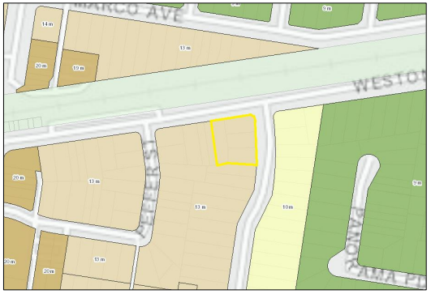

The maximum Height of Buildings, pursuant to the CBLEP 2023, is 13m. Part 2, Division 1, Clause 18(2) development standard of the Housing SEPP permits an additional 30% height bonus on top of cl4.3 of the CBLEP 2023 (based on 100% affordable housing provision), resulting in a maximum height of building of 16.9m.

The development proposes a maximum building height of 17.44m, exceeding the maximum permissible height by 0.54m, as shown in the height plane diagram below.

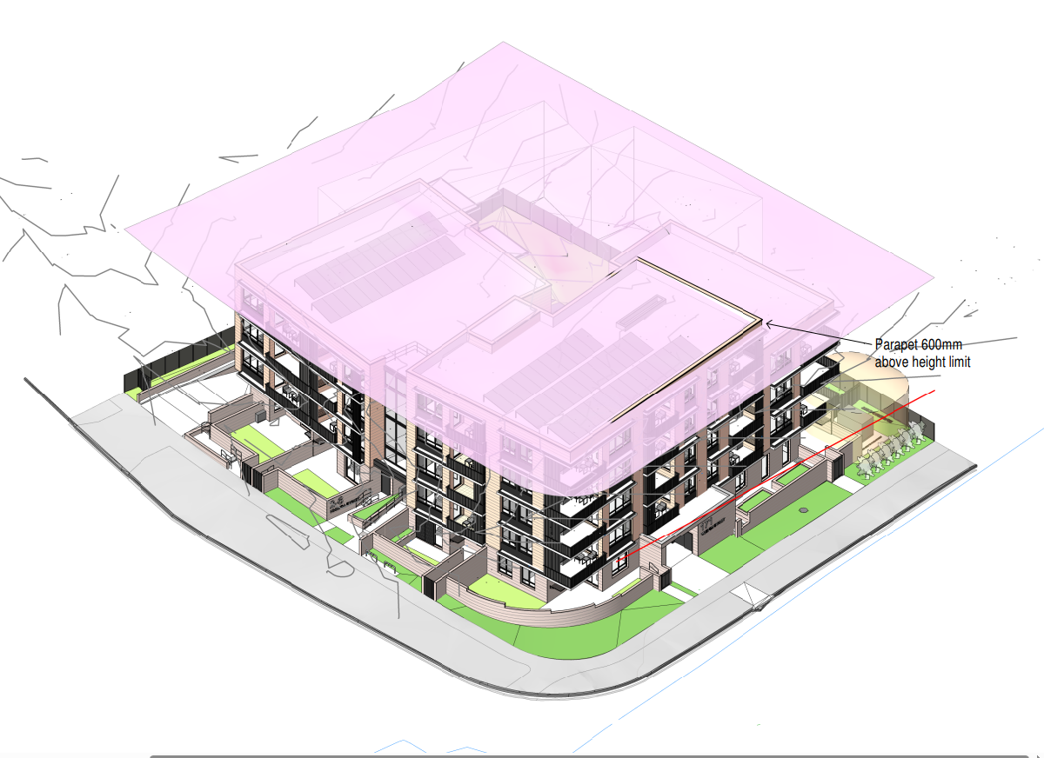

Clause 4.6(4) of the LEP establishes preconditions that must be satisfied before a consent authority can exercise the power to grant development consent for development that contravenes a development standard. Clause 4.6(2) provides this permissive power to grant development consent for a development that contravenes the development standard is subject to conditions.

These matters are considered below for the proposed development having regard to the applicant’s Clause 4.6 request

**Clause 4.6(3)(a) – Development standard is unreasonable or unnecessary**

Clause 4.6 (3)(a) states:

*“(3) Development consent must not be granted to development that contravenes a development standard unless the consent authority is satisfied the applicant has demonstrated that— (a) compliance with the development standard is unreasonable or unnecessary in the circumstances,”*

The applicant has submitted a Clause 4.6 request, providing the following reasons as to why compliance with the development standard is considered unreasonable or unnecessary in the circumstances:

* *The proposed development achieves the objectives of the height of buildings standard and is consistent with the objectives of the zone notwithstanding non-compliance with the standard.*
* *The height variation is necessary as the parapet forms an integral component of the architectural expression of the affordable housing development and is key to the developments design excellence. Strict compliance with the standard would result in a sub-optimal architectural outcome that would not result in any additional benefit to the amenity of the surrounding properties.*
* *The non-compliance would not result in any unreasonable environmental or amenity impacts.*
  + *The proposed development provides for outcomes which are consistent with the development standards which are relevant to the privacy, amenity and solar access as applicable to both the development site internally and externally.*
  + *The development’s partial height exceedance will not result in the loss, or disruption of any views. The site and surrounding area sits within gently undulating terrain, where no unique vistas dominate, or are required to be preserved.*
  + *There is no development opposite the site to which the height exceedance faces, only the railway line, the streetscape of Weston Street is open in nature and therefore the focussing of the higher portion of the development toward the front of the site will not result in an overbearing visual impact on the street.*

The proposed development’s non-compliance with the maximum building height standard is considered both justifiable and reasonable, as it contributes to achieving architectural design excellence and meeting the functional requirements of the project. The height variation is integral to the overall design, with minimal impact on the surrounding environment, including privacy, amenity, and solar access. The proposal has been thoughtfully designed to ensure compatibility with the existing streetscape and neighbouring properties, resulting in minimal visual intrusion. It maintains a respectful relationship with its context, and the departure from the height standard does not give rise to any unreasonable environmental or amenity impacts.

**Clause 4.6(3)(b) - Sufficient environmental planning grounds exist to justify the contravention**

Clause 4.6 (3)(b) states:

*“(3) Development consent must not be granted to development that contravenes a development standard unless the consent authority is satisfied the applicant has demonstrated that—*

1. *there are sufficient environmental planning grounds to justify the contravention of the development standard.”*

There are sufficient environmental planning grounds to justify contravening the height of buildings development standard under the CBLEP 2023. The development is consistent with:

* The objectives of Clause 4.3 Height of buildings;
* Objectives of the R4 High Density Residential zone; and
* Relevant legislation, plans and strategies

These matters are addressed by the applicant in their Clause 4.6 and are detailed below:

Objectives of Clause 4.3 Height of buildings:

1. *to establish the height of development consistent with the character, amenity and landform of the area in which the development will be located,*

*“The height of the proposed development is compatible with the desired future development in the surrounding area, which is identified for the purposes of higher density residential developments, such as that proposed.*

*Furthermore, only 190m to the west of the site, building height limits are further increased, with permissible heights of between 19-20m. In the context of these controls the proposed development will transition consistently in the streetscape with surrounding development.”*

1. *to maintain the prevailing suburban character and amenity by limiting the height of development to a maximum of 2 storeys in Zone R2,*

*“Not applicable in this instance as the Zoning of the site is R4 High Density Residential.”*

1. *to provide appropriate height transitions between development, particularly at zone boundaries,*

*“The proposed rooftop parapet has been designed so that the height breach is located centrally within the site and is away from side and rear façades. This has allowed for increased separation from adjoining properties and the front boundary, minimising the impact of the additional building height on adjoining properties and the streetscape, and allows for an appropriate transition in scale from the subject site to the adjoining properties.”*

1. *to minimise overshadowing to existing buildings and open space,*

“*The Shadow diagrams within the Architectural Plans show that the adjoining dwellings will continue to receive sufficient mid-winter solar access to primary living and open space areas. Any additional shadowing as a result of the height exceedance is considered to be negligible and is likely to be contained wholly within the site. The shadow diagrams study show that the proposed development does not have significant impacts on the neighbouring property to the south (8 Hinemoa Street).”*

1. *to minimise the visual impact of development on heritage items and heritage conservation areas,*

*“The site is not within the visual catchment of the heritage item, and the development will have no impact upon heritage settings. Accordingly, this objective is not considered to be relevant to the proposal in terms of the impact of the proposed additional building height.”*

1. *to support building design that contributes positively to the streetscape and visual amenity of an area.*

*“The development contributes positively to the streetscape and the visual amenity of the area through a contemporary design that is consistent with the bulk, height, scale and setback of other emerging modern residential flat building developments in the surrounding locality, and which is consistent with the desired future character of the area.”*

Objectives of the R4 High Density Residential Zone:

The site is identified within the R4 High Density Residential zone under the CBLEP 2023. The objectives of the R4 zone are addressed by the applicant below:

1. Objectives of zone

* *To provide for the housing needs of the community within a high-density residential environment.*
* *To provide a variety of housing types within a high-density residential environment.*
* *To enable other land uses that provide facilities or services to meet the day to day needs of residents.*
* *To minimise conflict between land uses within this zone and land uses within adjoining zones.*
* *To allow for increased residential density in accessible locations to maximise public transport patronage and encourage walking and cycling.*
* *To promote a high standard of urban design and local amenity.*

*“The proposed development aligns with the objectives of the R4 zone, addressing the community's housing needs in a high-density residential environment. It offers a variety of housing types, including adaptable units, in response to the need for social and affordable housing in the Canterbury Bankstown LGA. The development will not obstruct surrounding land from providing essential services or facilities to meet the day to day needs of the residents. The building design incorporates a stepped top floor to minimize the height impact on neighbouring properties and the streetscape, ensuring an appropriate transition in scale.*

*The contemporary design is consistent with the surrounding locality’s emerging modern character, and the development minimises potential adverse impacts while enhancing resident amenity. Sustainable features, including thermal performance, solar access, energy and water efficiency, and rooftop solar panels, have also been integrated.”*

The Clause 4.6 request has been reviewed and is considered satisfactory in demonstrating that strict compliance with the development standard is unnecessary in this instance. The variation is well-justified, with the proposal achieving the objectives of the standard and delivering an acceptable planning outcome. The request appropriately addresses the relevant criteria and supports the conclusion that the departure from the standard will not result in any adverse environmental or amenity impacts.

1. **Section 4.15(1)(a)(iii) - Provisions of any Development Control Plan**

The following Development Control Plan is relevant to this application:

* *Canterbury Bankstown Development Control Plan 2023* (‘the DCP’)

Chapter 3.1 Development Engineering Standards

The application was referred to Council’s Development Engineers for their consideration. They raised concerns regarding the stormwater management plan and basement layout. The applicant addressed these concerns in the amended set of plans. No further objections were raised, subject to conditions.

Chapter 3.3 Waste Management

The application was referred to Council’s Resource Recovery team for their consideration. No objections were raised, subject to conditions.

Chapter 5.1 Residential Accommodation (Former Bankstown)

An assessment of the proposed design against the relevant provisions of Section 8 – Residential flat buildings and shop top housing in Zone R4, is provided in the table below:

| **CANTERBURY BANKSTOWN DEVELOPMENT CONTROL PLAN 2023**  **CHAPTER 5.1 RESIDENTIAL ACCOMMODATION (FORMER BANKSTOWN)** | | | | | |
| --- | --- | --- | --- | --- | --- |
|  | | | Compliance | | |
| Y | N | N/A |
| **SECTION 8 – RESIDENTIAL FLAT BUILDINGS AND SHOP TOP HOUSING IN ZONE R4** | | | | | |
| **8.1**  **Isolation of sites** | Development on land within Zone R4 High Density Residential is not to result in a site adjoining such land having an area of less than 1,000m2 or a width of less than 20 metres at the front building line for the purpose of multi dwelling housing. | The development does not result in the isolation of any adjoining sites | x |  |  |
| **8.2**  **Storey limit** | Development must comply with the storey limit that corresponds with the maximum building height shown for the site on the Height of Building Map as follows: | The development does not comply with this control, however the proposal benefits from provisions in the Housing SEPP which prevail over the DCP and allow for a building height of 16.9m |  | x |  |
| |  |  | | --- | --- | | Maximum building height as shown on the Height of Buildings Map (Canterbury Bankstown LEP 2023) | Storey limit (not including basements) | | 13m | 4 storeys (no attic) | | 16m | 5 storeys (no attic) | | 19m | 6 storeys (no attic) | | 25m | 8 storeys (no attic) | | |
|  | |
| **8.3**  **Storey limit** | The siting of residential flat buildings, shop top housing and landscape works must be compatible with the existing slope and contours of the site and any adjoining sites. Council does not allow any development that involves elevated platforms on columns; or excessive or unnecessary terracing, rock excavation, retaining walls or reclamation. | The proposed development is compatible with the natural topography of the site. Minimal filling of the site is proposed. | x |  |  |
| **8.4**  **Storey limit** | Any reconstituted ground level on the site must not exceed a height of 600mm above the natural ground level of an adjoining site except where:   1. the residential flat building or shop top housing is required to be raised to achieve a suitable freeboard in accordance with Chapter 2.2 of this DCP; or 2. the fill is contained within the ground floor perimeter of the residential flat building or shop top housing to a height no greater than 1 metre above the natural ground level of the site. | The extent of the required fill is isolated within the building’s ground floor permitter and associated terrace garden beds.  A maximum fill of +0.960m is proposed for a reconstituted ground level within the building perimeter. | x |  |  |
| **8.5**  **Street setbacks** | The minimum setback for a building wall to the primary street frontage is:   1. 3 metres for the sites at 1–9 Leonard Street and 74–80 Restwell Street in Bankstown; and 2. 6 metres for all other sites. | A front setback of 6m for all building elements is required. The proposal includes a minor encroachment of the waste room on the Weston St frontage, which is setback only 3.6m.  This has been proposed to facilitate Council’s waste collection and ensure that the waste room is not more than 10m from the street kerb. |  | x |  |
| **8.6**  **Street setbacks** | The minimum setback for a building wall to the secondary street frontage is 6 metres. | Ground floor terraces and balconies in some instances protrude into the minimum setback, however this is considered acceptable as it provides for a level of street activation at ground, ensures that passive surveillance of the street can be achieved and provides for high quality POS at ground level. |  | x |  |
| **8.8**  **Side and rear setbacks** | For a building with 3 or more storeys, the minimum setback to the side and rear boundaries of the site is 4.5 metres provided the average setback is 0.6 multiplied by the wall height. | Levels 1-4 are setback 6m from the side boundary to building wall.  The balconies on levels 2-4 encroach within this setback by 0.3m, however adverse impacts are mitigated with privacy screening.  Level 5 is setback 15.2m from the side boundary.  Rear (3+ storeys):  Ground Level is 8.1m to building wall. Levels 1-3 are 6m to building wall.  Level 4 is setback 26m from the rear boundary to the building wall. |  | x |  |
| **8.10**  **Side and rear setbacks** | The minimum setback for a basement level to the side and rear boundaries of the site is 2 metres. | The basement is setback 7.9m to the side boundary and 10.4m to the rear boundary | x |  |  |
| **8.11**  **Side and rear setbacks** | The minimum setback for a driveway to the side and rear boundaries of the site is 1 metre. | The development proposes a side setback of 1.4m to the basement vehicle ramp | x |  |  |
| **8.12**  **Private open space** | Development must locate the private open space behind the front building line. This clause does not apply to any balconies where it is used to provide articulation to the street facade. | Units 2-6 have POS terraces that are forward of the building line. These ground level spaces will assist in activating the streetscape. The upper-level balconies will provide articulation to the façade and are at most, 400mm forward of the building line.  The communal open space is located wholly behind the building line |  | x |  |
| **8.13**  **Building design** | Council applies State Environment Planning Policy No. 65–Design Quality of Residential Apartment Development and the Apartment Design Guide to residential flat buildings and shop top housing. This includes buildings that are two storeys or less, or contain less than four dwellings. | In December 2023, SEPP65 was repealed and replaced with Chapter 4 of the Housing SEPP which is relevant to and applies to this Development Application. | x |  |  |
| **8.14**  **Building design** | Development for the purpose of residential flat buildings and shop top housing must demolish all existing dwellings (not including any heritage items) on the site. | All existing buildings on the site are proposed for demolition | x |  |  |
| **8.15**  **Building design** | The maximum roof pitch for residential flat buildings and shop top housing is 35 degrees. | The proposed development incorporates a flat roof | x |  |  |
| **8.18**  **Building design** | Council does not allow residential flat buildings and shop top housing with 4 or more storeys to have attics. | An attic has not been proposed | x |  |  |
| **8.19**  **Building design** | Council does not allow residential flat buildings and shop top housing to have roof–top balconies and the like. | No roof-top balconies have been proposed | x |  |  |
| **8.20**  **Building design** | The siting of a plant room, lift motor room, mechanical ventilation stack, exhaust stack, and the like must:   1. integrate with the architectural features of the building to which it is attached; or 2. be sufficiently screened when viewed from the street and neighbouring sites. | The building services and plant room has been integrated into the design of the building. The above ground substation has been sufficiently screened through the use of landscaping. | x |  |  |
| **8.21**  **Building design (car parking)** | Development must locate the car parking spaces behind the front building line. | The development proposes basement carparking |  |  | x |
| **8.22**  **Landscape** | Development must retain and protect any significant trees on the site and adjoining sites. To achieve this clause, the development may require a design alteration or a reduction in the size of the residential flat building and shop top housing. | The proposal requires the removal of 1 high retention value tree, 1 medium retention value tree in the road reserve, and 11 low retention value trees on site. Two high retention value trees are retained on site, and additional canopy tree planting will be provided as shown in the landscape scheme submitted with the development application.  The proposal has been reviewed by Council’s Tree Management Team who raised no objections to the proposal subject to conditions. | x |  |  |
| **8.23**  **Landscape** | Development must landscape the following areas on the site by way of trees and shrubs with preference given to native vegetation endemic to Canterbury Bankstown (refer to the Landscape Guide for a list of suitable species):   1. a minimum 45% of the area between the building and the primary street frontage; and 2. a minimum 45% of the area between the building and the secondary street frontage; and 3. plant more than one 75 litre tree between the building and the primary street frontage (refer to the Landscape Guide for a list of suitable trees in Canterbury Bankstown); or    1. if the site adjoins the Hume Highway and the minimum setback to the Hume Highway is less than 20 metres, the development must plant a row of 75 litre trees at 5 metre intervals along the length of the Hume Highway boundary and must select the trees from the Landscape Guide; or    2. if the site adjoins the Hume Highway and the minimum setback to the Hume Highway is 20 metres, the development must plant two rows of 75 litre trees at 5 metre intervals along the length of the Hume Highway boundary and must select the trees from the Landscape Guide. | The proposal demonstrates a landscaped area forward of the building line: 51.4%, or 314.4m2.  Additionally, the development proposes to plant more than one 75L canopy tree. | x |  |  |

1. **Section 4.15(1)(a)(iiia) – Planning agreements under Section 7.4 of the EP&A Act**

There have been no planning agreements entered into and there are no draft planning agreements being proposed for the site.

1. **Section 4.15(1)(a)(iv) - Provisions of Regulations**

Section 61 of the EP&A Regulation 2021 contains matters that must be taken into consideration by a consent authority in determining a development application, with the following matters being relevant to the proposal:

* If demolition of a building proposed - provisions of AS 2601;

Section 62 (consideration of fire safety) and Section 64 (consent authority may require upgrade of buildings) of the EP&A Regulation 2021 are not relevant to the proposal.

These provisions of the EP&A Regulation 2021 have been considered and are addressed in the recommended draft conditions (where necessary).

* 1. **Section 4.15(1)(b) - Likely Impacts of Development**

The likely impacts of that development, including environmental impacts on both the natural and built environments, and social and economic impacts in the locality must be considered. In this regard, potential impacts related to the proposal have been considered in response to SEPPs, LEP and DCP controls outlined above and the Key Issues section below.

The consideration of impacts on the natural and built environments includes the following:

* Context and setting – There are no prohibitive constraints posed by adjacent developments. There are no zoning, planning or environmental matters that should hinder the proposed development of the site. In this regard, it has been demonstrated that the proposal fits into the locality and are contextually appropriate the site attributes are conducive for the development.
* Access and traffic – Stanbury Traffic Planning have prepared a Traffic and Parking Assessment report, which finds that there will be no adverse traffic impacts to the local road network because of the development, noting that the development results in a slight increase of 5 additional vehicle trips per hour in peak time within the surrounding road network. The development itself will provide 19 car parking spaces, including 5 accessible car parking spaces and 6 bicycle racks, which will be accessible via the combined entry and exit driveway located on the Hinemoa Road frontage. The proposed number of car parking spaces satisfies the non-discretionary development standards found in Section 19(2)(e) of the Housing SEPP, as the development proposes affordable housing within an accessible area in the ‘Six Cities Region’ (19 required, 19 provided). An assessment of the car park layout, including the proposed parking spaces and associated aisle width, indicate the car park layout is generally complaint with the relevant applicable standards (AS2890.1 – 2004 and AS2890.6 – 2009).
* Heritage – An Aboriginal Heritage Information Management System (AHIMS) search, dated 26 August 2024 has not found any record of Aboriginal Sites or Places on the site or in the surrounding locality. Consideration of the Due Diligence Code of Practice for the Protection of Aboriginal Objects in New South Wales determines that no additional investigation is warranted.
* Water/air/soils impacts - Soil erosion and sediment control measures have been designed in accordance with the guidelines set out in the Blue Book Managing Urban Stormwater: Soils and Construction. The CBLEP 2023 Acid Sulfate Soils Map does not identify the subject site as being affected by Acid Sulfate Soils.

Temporary and localised air quality impacts including dust, smoke, grit, odours, and fumes could arise during the clearing and excavation of the site and construction of the proposed development. Appropriate mitigation measures will be put in place to ensure any potential impacts are minimised, including site watering or damp cloth fences, requiring all vehicles transporting loose materials and travelling on public roads to be secured (i.e., closed tail gate and covered) to minimise dust generation.

* Flora and fauna impacts - The site is not identified as containing any mapped areas of biodiversity sensitivity, Biodiversity Values or Critical Habitat. An Arboricultural Impact Assessment (Arborist Report) has been prepared by Newleaf Arboriculture. The Arborist Report considers 22 trees: 14 trees within the site; 1 tree in the adjacent property to the south and 7 trees within the road reserve. More appropriate tree plantings will be provided as part of the comprehensive landscaping scheme proposed for the site specifically designed to compensate for the loss of the trees to be removed.
* Noise and vibration – Any noise generated during the construction of the development will not exceed the limits specified in the July 2009 Interim Construction Noise Guidelines, published by the Department of Environment and Climate Change. An acoustic assessment was undertaken by Rodney Stevens Acoustics for the development. The impacts are mitigated with recommended conditions included in the consent, as contained at Attachment A, relating to noise and vibration, and maintaining the amenity of adjoining properties by ensuring compliance with the Protection of the Environment Operations Act, 1997, and implementing the recommendations of the acoustic report.
* Natural hazards – The development is located within the Flood Planning Area. Nos. 2, 4 & 6 Hinemoa Street are subject to overland flooding associated with excess run off from the upstream catchment and the drainage system through Hinemoa and Weston Streets. The site is identified as being a Medium Flood Risk area in the 100 Year ARI Flood Extent and Flood Contour Levels map. The submitted Flood Risk Management Report demonstrates that the proposed development suitably responds to the site’s flooding constraints
* Safety, security and crime prevention – The proposed development has been reviewed by Council’s Community Safety Officer. CPTED principles and strategies have been considered and addressed in the draft conditions.
* Social impact – The proposed development will have several positive community and social effects. The proposed development will:
  + assist Homes NSW in meeting its significant, long-standing and continually growing demand for social housing in the City of Canterbury-Bankstown Council local government and surrounding areas.
  + assist Homes NSW in improving the amenity of accommodation for its tenants, by providing new, more appropriate housing.
  + improve the environmental sustainability of housing on the site, particularly through improved thermal performance, solar access, natural ventilation, energy and water efficiency.
  + assist Homes NSW to grow its social housing portfolio in line with the NSW Government’s Future Directions for Social Housing in NSW.
  + assist City of Canterbury-Bankstown Council to increase the provision of affordable housing in the LGA.
* Economic impact – The proposed development is likely to contribute to a range of economic benefits in the City of Canterbury-Bankstown local government and surrounding areas through:
  + more efficient use of land resources, existing infrastructure and existing services.
  + local sourcing of construction materials where possible,
  + promotion of housing affordability, through the expansion of publicly owned social housing.
  + the local sourcing of tradespeople and other construction-related professionals, where possible.
  + ongoing consumption from new/additional households.
  + the reduced maintenance costs of the newer housing.
  + savings associated with improved energy and water efficiency
* Cumulative impacts – The proposed development activity is not likely to have any cumulative environmental impacts which are likely to combine with each other or with impacts of other activities to produce any unacceptable adverse effects for the following reasons:
  + the proposed development activity will not result in any adverse cumulative impact when considered in conjunction with any other proposals or developments in the area.
  + there will be no synergistic effects of individual project impacts from the proposed development activity when considered in combination.
  + there are no known environmental stresses in the area affected by the proposed development activity or likely contribution of the proposed activity to increasing or decreasing those stresses

Accordingly, it is considered that the proposal will not result in any significant adverse impacts in the locality as outlined above.

* 1. **Section 4.15(1)(c) - Suitability of the site**

Based on the above assessment, the site is suitable for the proposed development.

* 1. **Section 4.15(1)(d) - Public Submissions**

These submissions are considered in Section 5 of this report.

* 1. **Section 4.15(1)(e) - Public interest**

For the reasons outlined within this report, approval of the proposed development would be in the public interest.

# REFERRALS AND SUBMISSIONS

* 1. **Agency Referrals and Concurrence**

The development application has been referred to various agencies for comment/concurrence/referral as required by the EP&A Act and outlined below in Table 5.

There are no outstanding issues arising from these concurrence and referral requirements subject to the imposition of the recommended conditions of consent being imposed.

**Table 5: Concurrence and Referrals to agencies**

|  |  |  |  |
| --- | --- | --- | --- |
| **Agency** | **Concurrence/**  **referral trigger** | **Comments**  **(Issue, resolution, conditions)** | **Resolved** |
| Concurrence Requirements (s4.13 of EP&A Act) | | | |
| TfNSW | Section 2.99(4) - State Environmental Planning Policy (Transport and Infrastructure) 2021 | The proposal involves the excavation of ground to a depth of at least 2m below ground level (existing) on land within 25m of a rail corridor.  Concurrence has been granted subject to the below conditions.   1. Prior to the commencement of works, the Applicant shall provide an accurate survey locating the development with respect to the Transport Asset Holding Entity (TAHE) property boundary, rail corridor and rail infrastructure to Sydney Trains. This work is to be undertaken by a registered surveyor, to the satisfaction of Sydney Trains’ representative. 2. Prior to the commencement of works, the Applicant is to engage an Electrolysis Expert to prepare a report on the Electrolysis Risk to the development from stray currents. The Applicant must incorporate in the development all the measures recommended in the report to control that risk. The Applicant must ensure that the recommendations of the electrolysis report are incorporated in the construction drawings and documentation prior to the commencement of any works. 3. Prior to the commencement of any works, the Applicant must submit to Sydney Trains a plan showing all craneage and other aerial operations for the development and must comply with all Sydney Trains requirements. If required by Sydney Trains, the Applicant must amend the plan showing all craneage and other aerial operations to comply with all Sydney Trains requirements. Works shall not commence until written confirmation has been received from Sydney Trains confirming that this condition has been satisfied. 4. Prior to occupation of the development, a report must be prepared and submitted to Council and Sydney Trains confirming that the completed development meets the requirements of State Environmental Planning Policy (Infrastructure) 2007 and with the Department of Planning and Infrastructure’s Development Assessment Guideline titled “Development Near Rail Corridors and Busy Roads - Interim Guidelines”. Such a report must include external and internal noise levels to ensure that the external noise levels during the test are representative of the typical maximum levels that may occur at this development, and that internal noise levels meet the required dB(A) levels. Where it is found that internal noise levels are greater than the required dB(A) level, necessary corrective measures must be carried out to ensure that internal noise levels are compliant with the requirements of this consent. 5. Copies of any certificates, drawings, approvals/certification, or documents endorsed by, given to, or issued by Sydney Trains or TAHE (Transport Asset Holding Entity) must be submitted to Council for its records prior to construction works or occupation of the development. 6. The Applicant must ensure that at all times they have a representative (which has been notified to Sydney Trains in writing), who:  * oversees the carrying out of the Applicant’s obligations under the conditions of this consent and in accordance with correspondence issued by Sydney Trains; * acts as the authorised representative of the Applicant; and * is available (or has a delegate notified in writing to Sydney Trains that is available) on a 7 day a week basis to liaise with the representative of Sydney Trains, as notified to the Applicant.  1. Without in any way limiting the operation of any other condition of this consent, the Applicant must, during demolition, excavation and construction works, consult in good faith with Sydney Trains in relation to the carrying out of the development works and must respond or provide documentation as soon as practicable to any queries raised by Sydney rains in relation to the works. 2. Where a condition of consent requires consultation with Sydney Trains, the Applicant shall forward all requests and/or documentation to the relevant Sydney Trains External Interface Management team. In this instance the relevant interface team is West Interface, and they can be contacted via email on West_Interface@transport.nsw.gov.au. | Y |
| Referral/Consultation Agencies | | | |
| Ausgrid | Section 2.48 – State Environmental Planning Policy (Transport and Infrastructure) 2021  Development near electrical infrastructure | The proposal involves the penetration of ground within 2m of an underground electricity power line or an electricity distribution pole or within 10m of any part of an electricity tower,  The application has been reviewed by Ausgrid who have provided the following conditions:  Ausgrid Underground Cables are in the vicinity of the development.  Special care should be taken to ensure that driveways and any other construction activities do not interfere with existing underground cables located in the footpath or adjacent roadways.    It is recommended that the developer locate and record the depth of all known underground services prior to any excavation in the area. Information regarding the position of cables along footpaths and roadways can be obtained by contacting Before You Dig Australia (BYDA)  In addition to BYDA the proponent should refer to the following documents to support safety in design and construction:   * SafeWork Australia – Excavation Code of Practice. * Ausgrid’s Network Standard NS156 which outlines the minimum requirements for working around Ausgrid’s underground cables.   The following points should also be taken into consideration.   * Ausgrid cannot guarantee the depth of cables due to possible changes in ground levels from previous activities after the cables were installed. * Should ground levels change above Ausgrid’s underground cables in areas such as footpaths and driveways, Ausgrid must be notified, and written approval provided prior to the works commencing. * Should ground anchors be required in the vicinity of Ausgrid underground cables, the anchors must not be installed within 300mm of any cable, and the anchors must not pass over the top of any cable.   Ausgrid Overhead Powerlines are in the vicinity of the development.  The developer should refer to SafeWork NSW Document – Work Near Overhead Powerlines: Code of Practice. This document outlines the minimum separation requirements between electrical mains (overhead wires) and structures within the development site throughout the construction process. It is a statutory requirement that these distances be maintained throughout the construction phase.  Consideration should be given to the positioning and operating of cranes, scaffolding, and sufficient clearances from all types of vehicles that are expected be entering and leaving the site.  The “as constructed” minimum clearances to the mains must also be maintained. These distances are outlined in the Ausgrid Network Standard, NS220 Overhead Design Manual. This document can be sourced from Ausgrid’s website at [www.ausgrid.com.au](http://www.ausgrid.com.au).  It is the responsibility of the developer to verify and maintain minimum clearances onsite. In the event where minimum safe clearances are not able to be met due to the design of the development, the Ausgrid mains may need to be relocated in this instance. Any Ausgrid asset relocation works will be at the developer’s cost.  New Driveways - Proximity to Existing Poles Proposed driveways shall be located to maintain a minimum clearance of 1.5m from the nearest face of the pole to any part of the driveway, including the layback, this is to allow room for future pole replacements. Ausgrid should be further consulted for any deviation to this distance.  New or modified connection  To apply to connect or modify a connection for a residential or commercial premises. Ausgrid recommends the proponent to engage an Accredited Service Provider and submit a connection application to Ausgrid as soon as practicable. Visit the Ausgrid website for further details; https://www.ausgrid.com.au/Connections/Get-connected | Y |
| Design Review Panel | Cl 145(1) – Housing SEPP  Advice of the Design Review Panel (‘DRP’) | The advice of the DRP has been considered in the proposal. | Y |
| Integrated Development (S 4.46 of the EP&A Act) | | | |
| N/A | | | |

* 1. **Council Officer Referrals**

The development application has been referred to various Council officers for technical review as outlined **Table 6.**

**Table 6: Consideration of Council Referrals**

|  |  |  |
| --- | --- | --- |
| **Officer** | **Comments** | **Resolved** |
| Engineering | Council’s Engineering Officer reviewed the submitted stormwater concept plan and parking layout and considered that there were no objections subject to conditions. | Y |
| Traffic | Council’s Traffic Engineering Officer reviewed the proposal and raised no concerns in relation to traffic generation and car parking subject to conditions. | Y |
| Building | Council’s Building Surveyor reviewed the proposal and considered that there were no objections subject to conditions. | Y |
| Health | Council’s Environmental Health Officer reviewed the proposal and raised no concerns subject to conditions. | Y |
| Waste | Council’s Resource Recovery Officer reviewed the submitted plans and waste management plan and raised no objections, subject to conditions. | Y |
| Tree Management | Council’s Tree Management Officer reviewed the application and associated Arboricultural Impact Assessment, and raised no concerns with the recommendations outlined within the report subject to conditions. | Y |

The outstanding issues raised by Council officers are considered in the Key Issues section of this report.

* 1. **Community Consultation**

The proposal was notified in accordance with the Council’s Community Participation Plan from 30 October 2024 until 20 November 2024. The notification included the following:

* A sign placed on the site;
* Notification letters sent to adjoining and adjacent properties (35);
* Notification on the Council’s website.

The Council received a total of 4 unique submissions. The issues raised in these submissions are considered in **Table 7**

**Table 7: Community Submissions**

|  |  |  |
| --- | --- | --- |
| **Issue** | **No of submissions** | **Council Comments** |
| Parking  Submissions raised concern the development will adversely impact on-street parking in the area | 4 | The application proposes 19 car parking spaces, including 5 accessible car parking spaces and 6 bicycle racks.  The proposed number of car parking spaces satisfies the non-discretionary development standards found in Section 19(2)(e) of the Housing SEPP, as the development proposes affordable housing within an accessible area in the ‘Six Cities Region’ (19 required, 19 provided). |
| Basement parking layout | 1 | Council’s Development Engineer and Traffic officer have reviewed the proposal and have raised concerns regarding the function of the basement layout. Amended plans have been since reviewed and have satisfactorily addressed the concerns.  An assessment of the car park layout, including the proposed parking spaces and associated aisle width, indicate the car park layout is generally complaint with the relevant applicable standards (AS2890.1 – 2004 and AS2890.6 – 2009). |
| Obstruction of views  Submission has raised concern that the proposed development would obstruct views from neighbouring sites. | 1 | No significant views or vistas will be obstructed as a result of the proposed development. |
| Character of the area  Submission has raised the concern that a five storey development would be out of character for the area | 1 | The proposed development has been designed to respond and contribute positively to the existing and desired future character of the locality. The local area is undergoing transition from low-density to a high-density residential environment, which is congruent with the current zoning that applies to the site. The proposed level of development is envisioned for this part of Panania by the CBLEP 2023, which is in a highly accessible precinct serviced by rail and bus public transport services and is in close proximity to the services and facilities of the Panania Town Centre.  The proposed development has been reviewed by the Design Review Panel, who have raised no objection to the contextual appropriateness. |
| Diversity in apartments  A submission has raised the concern that the provision of three-bedroom apartments would add more diversity and provide a better mix of housing. | 1 | Homes NSW has identified that in the City of Canterbury-Bankstown LGA, the greatest demand for social housing is for studio, 1- and 2-bedroom dwellings. At 30 June 2023 within the Bankstown allocation zone, which Panania is located in, the waiting time for a 1 bedroom dwelling is 5-10 years, and more than 10 years for a 2-bedroom dwelling. The proposed development has been designed to directly respond to this immediate need. |
| Visual Privacy  Submission has raised the concern that balconies would be overlooking neighbouring developments. | 1 | The development has been designed to maintain visual privacy through appropriate building separation distances as well as the offsetting of balconies and windows to avoid instances of overlooking. Furthermore, privacy screening on the proposed balconies has been implemented to ensure that privacy is protected for both the residents and neighbours. |
| Solar access  Submission has raised concern that neighbouring developments may be impacted by a loss of solar access. | 1 | The DCP requires that adjoining dwellings receive at least 3 hours of solar access during the mid-winter solstice. The Shadow Diagrams have modelled the overshadowing impacts to the adjoining properties. The diagrams demonstrate that the development maintains 3 hours of solar access to the primary living areas of the adjoining dwellings between the hours of 8am-4pm during the mid-winter solstice. The development also maintains at least 3 hours of solar access to the private open space of the adjoining dwellings during the equinox.  The overall building extent was supported by the Canterbury-Bankstown Design Review Panel as demonstrating a positive transition in scale and being contextually appropriate. The proposed development demonstrates a compliant design solution which limits overshadowing and provides reasonable solar access to surrounding adjoining properties. |
| Building height  Submission has raised concern about the proposed breach of wall height. | 1 | A clause 4.6 variation request has been provided in support of the building height breach. The proposed development's non-compliance with the maximum height of buildings standard is justifiable and reasonable due to its contribution to achieving architectural design excellence and meeting the functional needs of the development. The height variation is integral to the development’s overall design. Furthermore, its impact on the surrounding environment, privacy, amenity, and solar access is minimal. The proposal has been carefully designed to ensure compatibility with the existing streetscape and neighbouring properties, with minimal visual impact. The development maintains a respectful relationship with the surrounding area, and the non-compliance with the height standard does not result in any unreasonable environmental or amenity impacts. |

# KEY ISSUES

The following key issues are relevant to the assessment of this application having considered the relevant planning controls and the proposal in detail:

* 1. **Visual privacy (Building Separation)**

Objective 3F of the ADG sets out the minimum required separation distances from buildings to the side and rear boundaries. A minimum 6m setback to the side and rear boundaries is required for habitable rooms and balconies of buildings comprising of 4 storeys to provide appropriate building separation for maintaining amenity and visual privacy between buildings.

The development meets the minimum setback requirements to the side and rear boundaries as required of the ADG, with the exception to the following:

* Side setback from the balconies of units 9,10,19,20,29,30 at 5.7 metres
* Internal separation between windows and balconies on levels 2 and 3

Resolution: Despite the non-compliance, the intent of Objective 3F-1 of the ADG is considered to be met through the design of the development by way of providing architectural elements and features that allow for reasonable levels of external and internal visual privacy and amenity.

* 1. **Public Domain Interface**

Objective 3C-2 of the ADG requires that substations be located in basement levels or away from view from the public domain. The substation for the development is proposed within the front setback of the building situated along the street frontage on the western end of the site and is positioned such that it does not conflict with other required services for the development.

Resolution: The application was referred to Ausgrid for review, who raised no objection to the proposed location, subject to conditions that form part of the recommended consent at Attachment A.

* 1. **Private open space**

Objective 4E-1 requires that apartments on the ground level are provided with private open space with a minimum area of 15m2. Unit 1 fails to comply as it provides a terrace with an area of 14.2m2 due to setback requirements.

Resolution: The extent of the departure is minimal and will not provide for any appreciable impacts for the occupants of the unit.

* 1. **Height of building**

The development fails to comply with Part 2, Division 1, Clause 18(2) of the Housing SEPP. The maximum Height of Buildings as per this development standard, pursuant to the CBLEP 2023, is 13m. Part 2, Division 1, Clause 18(2) development standard of the Housing SEPP permits an additional 30% in height in addition to cl4.3 of the CBLEP 2023 (based on 100% affordable housing provision), resulting in a maximum allowable height of building of 16.9m.

The development proposes a maximum building height of 17.44m, exceeding the maximum permissible height by 0.54m.

Resolution:

The breach to the height of building development standard under Clause 4.3(2) of the LEP has been resolved through the Clause 4.6 request, which successfully demonstrates that there are sufficient environmental planning grounds to justify the contravention.

# CONCLUSION

The proposed development has been designed in accordance with the Housing SEPP and the associated ADG to respond and contribute positively to the existing and emerging character of the locality. The proposal demonstrates that it is not likely to have an adverse effect on the environment and would not cause unacceptable environmental risks to the land. Careful consideration has been given to the massing of the built form and the relationship of the proposal with surrounding properties and streetscape. Careful consideration has also been given to the specific characteristics of the site, including topography and orientation of the lots to minimise environmental impacts and maximise tenant amenity. The proposal is considered to fit into the locality and the site attributes are conducive for the development.

The application demonstrates that the proposed development would not result in any unacceptable adverse environmental impacts and the proposed development is considered suitable for the site and its surrounds, despite the departure to the height of building development standard.

The proposed development would also provide much needed social housing to meet the needs of the community, assisting Homes NSW to meet the growing demand for social housing in the Canterbury-Bankstown local government area and surrounding areas.

This development application has been considered in accordance with the requirements of the EP&A Act and the Regulations as outlined in this report. Following a thorough assessment of the relevant planning controls, issues raised in submissions, and the key issues identified in this report during the assessment, it is considered that the application can be supported. Accordingly, it is requested that the development application be approved, subject to the conditions as recommended and contained in Attachment A.

# RECOMMENDATION

That the Development Application DA-1049/2024 for the demolition of existing structures and construction of a 4-storey and 5-storey affordable housing residential flat building comprising 42 apartments, over basement carparking at 171 Weston Street & 2, 4 & 6 Hinemoa Street, Panania be APPROVED pursuant to Section 4.16(1)(a) of the *Environmental Planning and Assessment Act 1979* subject to the draft conditions of consent attached to this report at Attachment A.

The following attachments are provided:

* Attachment A: Draft Conditions of consent
* Attachment B: Approval from the Crown (applicant) for imposition of Conditions
* Attachment C: Architectural Plans
* Attachment D: Clause 4.6 Request
* Attachment E Design Verification Statement